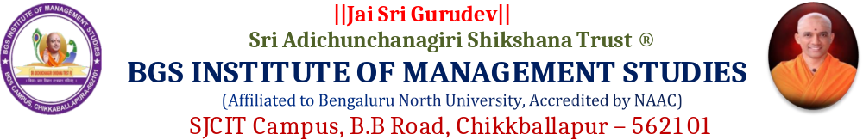

REPORT ON STUDY ABROAD AWARENESS PROGRAMME
1. | Title | “Study Abroad”
2. | Venue | BGSIMS Seminar Hall
3. | Date & Time | 07/09/2026 at 1.30 PM
4. | Resource Person | Ms. Sushma Kattaya and Ms. Poonam Pradeep
5. | Beneficiary Students | V sem B.Com & BBA Students
6. | Organised by. | BGS Institute of Management Studies, Chikkballapur.

BGS Institute of Management Studies (BGSIMS) organised a Study Abroad Awareness Programme for the final-year students of BBA and B.Com on 7 September 2026 at the BGSIMS Seminar Hall. The programme was organised with the objective of creating awareness among students about the various opportunities available for pursuing higher education abroad and helping them understand the academic, professional and career possibilities offered through international education. A total of 180 final-year students from BBA and B.Com actively participated in the programme.
The session was presented by Ms. Sushma Kattaya and Ms. Poonam Pradeep, who provided valuable information and guidance on different aspects of studying abroad. The resource persons introduced the students to various popular international study destinations and explained the importance of selecting an appropriate country, university and course based on individual academic qualifications, interests and career aspirations. The session helped students understand that proper planning and early preparation are important for successfully pursuing higher education opportunities at international institutions.
During the programme, detailed information was shared regarding the general admission and application process followed by universities abroad. The resource persons explained the importance of maintaining a good academic profile, preparing the required documents and completing applications within the prescribed timelines. Students were also made aware of the role of language proficiency and other entrance or eligibility requirements that may be applicable while seeking admission to institutions in different countries.
Special emphasis was given to the various postgraduate and professional programmes available to students after completing their BBA and B.Com degrees. The session provided guidance on identifying suitable courses that could support the students' future career goals and professional development. The resource persons also discussed the importance of understanding course content, duration, university requirements and future career prospects before making a decision regarding higher education abroad.
The programme further provided awareness about scholarships, financial planning and other possible funding opportunities available to international students. Students were encouraged to explore different options and prepare themselves in advance by understanding the estimated expenses associated with overseas education. Guidance was also provided on the importance of gathering authentic information, following proper procedures and seeking appropriate guidance while planning for international higher education.
An interactive discussion was conducted during the session, providing the 180 participating students with an opportunity to raise questions and clarify their doubts regarding course selection, eligibility, application procedures, scholarships and future career opportunities. The interaction enabled the students to gain a clearer understanding of the various steps involved in planning their higher education abroad. The resource persons addressed the queries of the participants and motivated them to explore opportunities that are suitable for their academic background and career interests.
The programme was highly informative and beneficial for the final-year BBA and B.Com students. It enhanced their awareness of global higher education opportunities and encouraged them to think beyond conventional career options. The session also helped students understand the importance of career planning, developing the required skills and preparing themselves well in advance for future academic and professional opportunities. The programme created greater interest among the participants in exploring international education as one of the possible pathways for their higher studies and career growth.
The informative presentation by Ms. Sushma Kattaya and Ms. Poonam Pradeep provided useful insights into the opportunities, requirements and planning involved in pursuing higher education abroad. The programme served as an effective platform for guiding students towards informed decision-making and supporting them in planning their future academic and career journeys. The programme concluded successfully with appreciation and gratitude to the resource persons for sharing their knowledge and valuable guidance with the students.
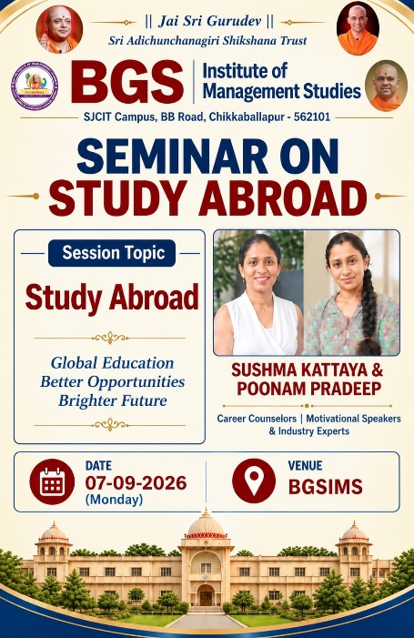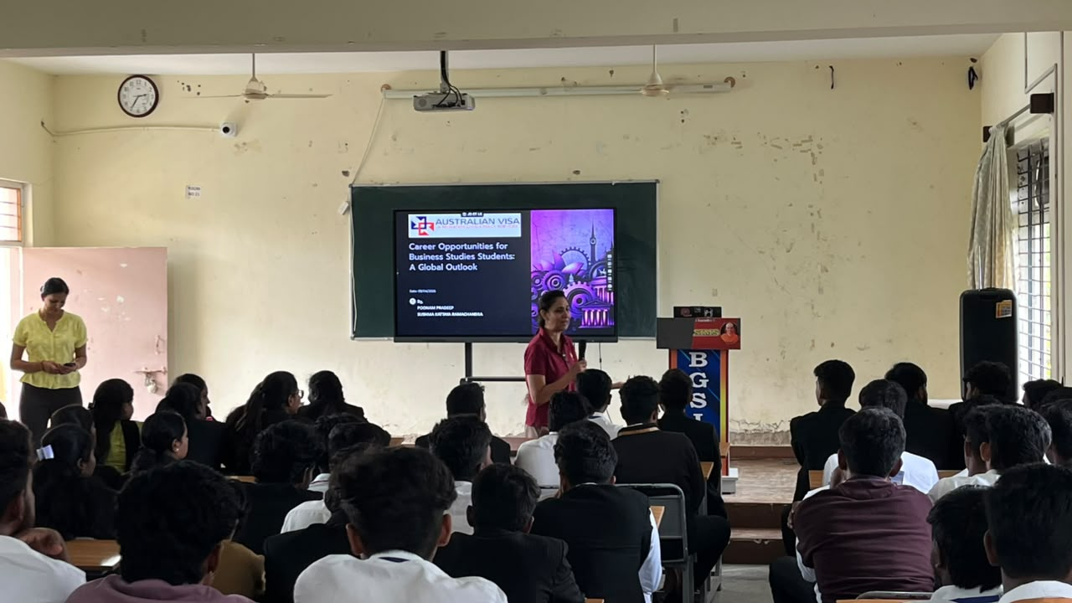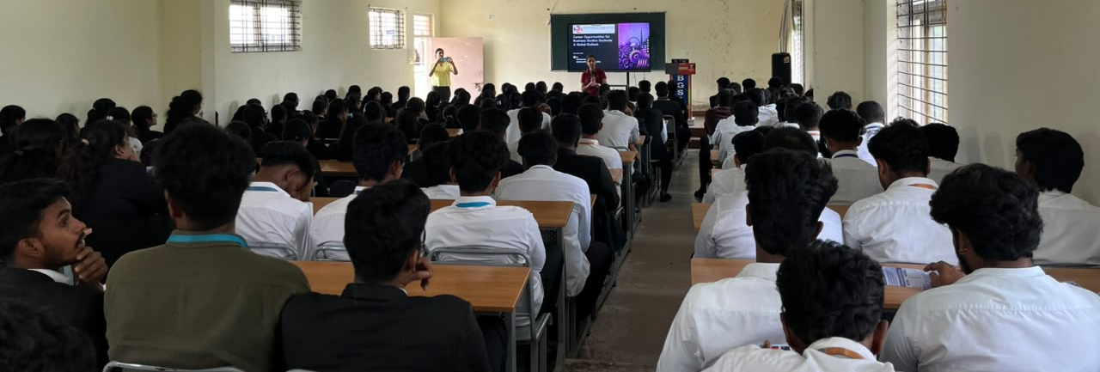

Co-Ordinator Academic Administrator Principal

