

REPORT ON THE WORKSHOP

“BUILDING A CULTURE OF SAFETY, RESPECT AND EQUALITY”
Date: 24 August 2026
Time: 10:30 AM
Venue: BGSIMS Seminar Hall
Target Group: Second-Year B.Com Students
Organized in accordance with: Internal Compliance Cell
Resource Person: Prof. Sreevidya Subramanya, Co-founder & Director, Suchinta Solutions Pvt. Ltd., Bengaluru
Presence: Prof. Ravichandra R, Academic Administrator, BGSIMS

Introduction
BGS Institute of Management Studies (BGSIMS) organized a workshop titled “Building a Culture of Safety, Respect and Equality” on 24 August 2026 at 10:30 AM at the BGSIMS Seminar Hall for the Second-Year B.Com students. The programme was conducted in accordance with the initiatives of the Internal Compliance Cell, with the objective of creating awareness among students about maintaining a safe, respectful, inclusive and harassment-free campus environment.
The workshop focused on three important areas of student safety and well-being: anti-ragging, prevention of harassment, and prevention of sexual harassment. The session emphasized the importance of mutual respect, dignity, equality, responsible behaviour and awareness of institutional mechanisms available to students.

Resource Person
The session was led by Prof. Sreevidya Subramanya, Co-founder & Director, Suchinta Solutions Pvt. Ltd., Bengaluru. Through her interaction with the students, she highlighted the importance of developing a culture where every individual feels safe, respected and valued.
Her practical approach and discussion of relevant situations helped students understand how inappropriate behaviour can affect individuals and the overall campus environment.

Objectives of the Workshop
The major objectives of the workshop were:
- To create awareness about anti-ragging practices and regulations.
- To sensitize students about different forms of harassment and inappropriate behaviour.
- To create awareness about the prevention of sexual harassment.
- To promote respect, equality, dignity and responsible conduct among students.
- To help students understand the importance of maintaining a safe and inclusive campus environment.
- To encourage students to speak up and seek appropriate support when they experience or witness unacceptable behaviour.
- To familiarize students with the importance of institutional mechanisms for addressing complaints and concerns.

Major Areas Covered

1. Anti-Ragging Awareness

The resource person explained the meaning and consequences of ragging and emphasized that ragging in any form should not be encouraged or tolerated. Students were made aware that behaviour presented as “fun” or “friendly interaction” can become harmful, humiliating or threatening when it affects another person's dignity or well-being. The session encouraged students to maintain healthy relationships with their peers and to contribute towards creating a campus free from intimidation, bullying and ragging.

2. Prevention of Harassment
The workshop addressed the different ways in which harassment can occur in educational environments. Students were encouraged to recognize inappropriate verbal, physical, psychological and online behaviour. The importance of respecting personal boundaries and treating fellow students with dignity was strongly emphasized. Students were also encouraged to report concerns through appropriate institutional channels rather than remaining silent.

3. Prevention of Sexual Harassment

A significant part of the workshop focused on awareness and prevention of sexual harassment. Students were sensitized about the importance of consent, personal boundaries, respectful communication and professional conduct. The resource person explained that students should understand what constitutes inappropriate conduct and should not hesitate to seek institutional support when faced with uncomfortable or unacceptable behaviour.

4. Culture of Safety, Respect and Equality
The central theme of the programme was the creation of a positive campus culture based on safety, respect and equality. Students were encouraged to understand that maintaining a safe environment is a shared responsibility. The session highlighted that differences in gender, background, opinions, abilities or personal choices should never become reasons for discrimination, humiliation or harassment. Students were encouraged to demonstrate empathy, respect others' boundaries and act responsibly both offline and online.

Interaction with Students
The workshop included an interactive session in which students had the opportunity to engage with the resource person and gain clarity on issues related to ragging, harassment and sexual harassment. The interactive nature of the programme helped students understand the practical implications of inappropriate behaviour and the importance of responding responsibly.
Students were encouraged to become responsible members of the institution and contribute actively towards building a campus environment that promotes dignity, equality and mutual respect.

Outcome of the Workshop
The workshop successfully created awareness among the Second-Year B.Com students regarding:
- The importance of maintaining a ragging-free campus.
- Recognition and prevention of different forms of harassment.
- Awareness about sexual harassment and inappropriate conduct.
- Respect for personal boundaries and individual dignity.
- The importance of equality, empathy and responsible behaviour.
- The need to report unacceptable behaviour through appropriate institutional mechanisms.

Conclusion
The workshop on “Building a Culture of Safety, Respect and Equality” was a meaningful awareness programme aimed at empowering students with knowledge about their responsibilities, rights and appropriate conduct. The session reinforced the importance of preventing ragging, harassment and sexual harassment and encouraged students to promote a culture of dignity, respect and equality. The programme served as an important initiative of the Internal Compliance Cell towards strengthening awareness and ensuring a safe, supportive and inclusive environment for students at BGSIMS. The workshop concluded with a renewed commitment to building a campus culture where every student feels safe, respected, valued and treated with dignity and equality.
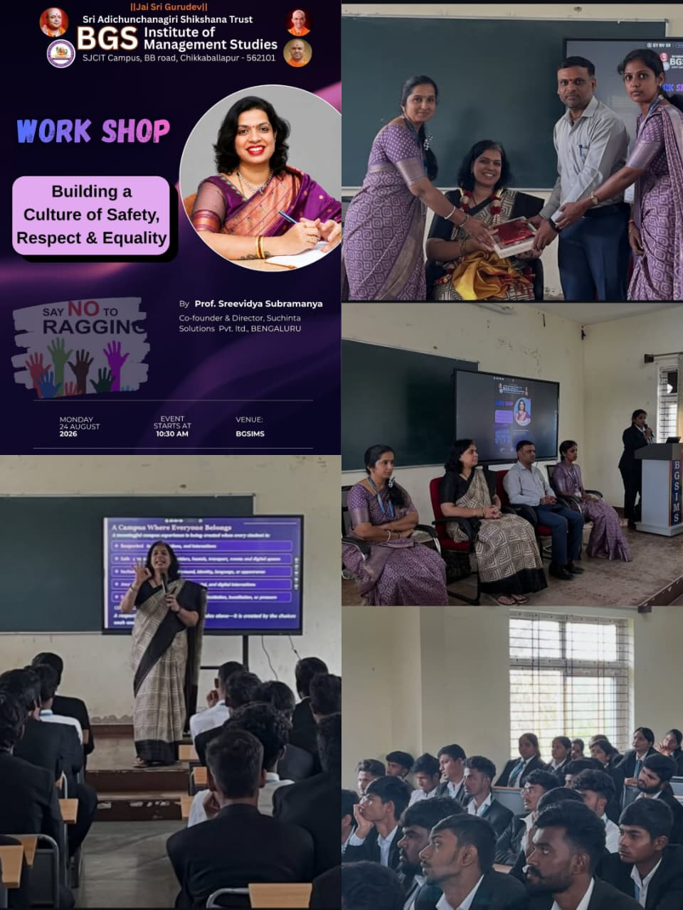

CO-ORDINATOR CONVENER IQAC CO-ORDINATOR PRINCIPAL
(Prof. Akhila J) (Prof. Kavitha) (Prof. Ravichandra R) (Prof. Manjunatha N)

