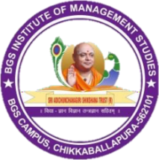
||Jai Sri Gurudev||August

Sri Adichunchanagiri Shikshana Trust ®
BGS INSTITUTE OF MANAGEMENT STUDIES
(Affiliated to Bengaluru North University, Accredited by NAAC)
SJCIT Campus, B.B Road, Chickballapur – 562101

CORPORATE GURU WORKSHOP REPORT ON - “READING THE MARKET”
 | Title - | “Reading the Market”
 | Venue - | BGSIMS, Seminar Hall
 | Date & Time - | 08/08/2026, 10.45 AM
 | Resource Person - | Mr. Sagar U S
 | Organization - | Stocktale
 | Designation - | Founder, Stocktale
 | Beneficiary Students - | V Sem BCOM & BBA Students of BGSIMS
 | Organized By - | BGS Institute of Management Studies, Chikkaballapur

The inaugural session was graced by Principal Mr. Manjunatha N, Academic Administrator Mr. Ravichandra R, Programme Coordinator Dr. Kavya Y R and Convenor Ms. Kavitha. The dignitaries welcomed the resource person, Mr. Sagar U S, Founder of Stocktale, and formally inaugurated the Corporate Guru Workshop. The programme was organised by BGS Institute of Management Studies, Chikkaballapur, to provide students with practical exposure to financial markets and investment awareness.
BGS Institute of Management Studies, Chikkaballapur organized a Corporate Guru Workshop on “Reading the Market” on 08th August 2026 at BGSIMS Seminar Hall from 10.45 AM. The session was conducted by Mr. Sagar U S, Founder of Stocktale. A total of 150 students from V SEM B.Com and BBA participated in the workshop and actively engaged with the resource person.
The workshop was organized to familiarize students with the fundamentals of reading and understanding the stock market. The resource person explained how market movements, financial news, market indicators and changing economic conditions can influence investment decisions. The session emphasized the importance of analysing information carefully before taking investment decisions.
The speaker also provided practical insights into financial-market awareness and encouraged students to develop analytical thinking, financial literacy and responsible investment habits. The interactive nature of the session enabled students to connect theoretical concepts learned in the classroom with real-world market practices.
The workshop benefited the participating students by enhancing their understanding of the stock market and the importance of informed decision-making. After the interaction with the students, the resource person was honoured as a token of appreciation. The programme concluded with a vote of thanks and appreciation to the resource person for his valuable contribution.

POSTER:
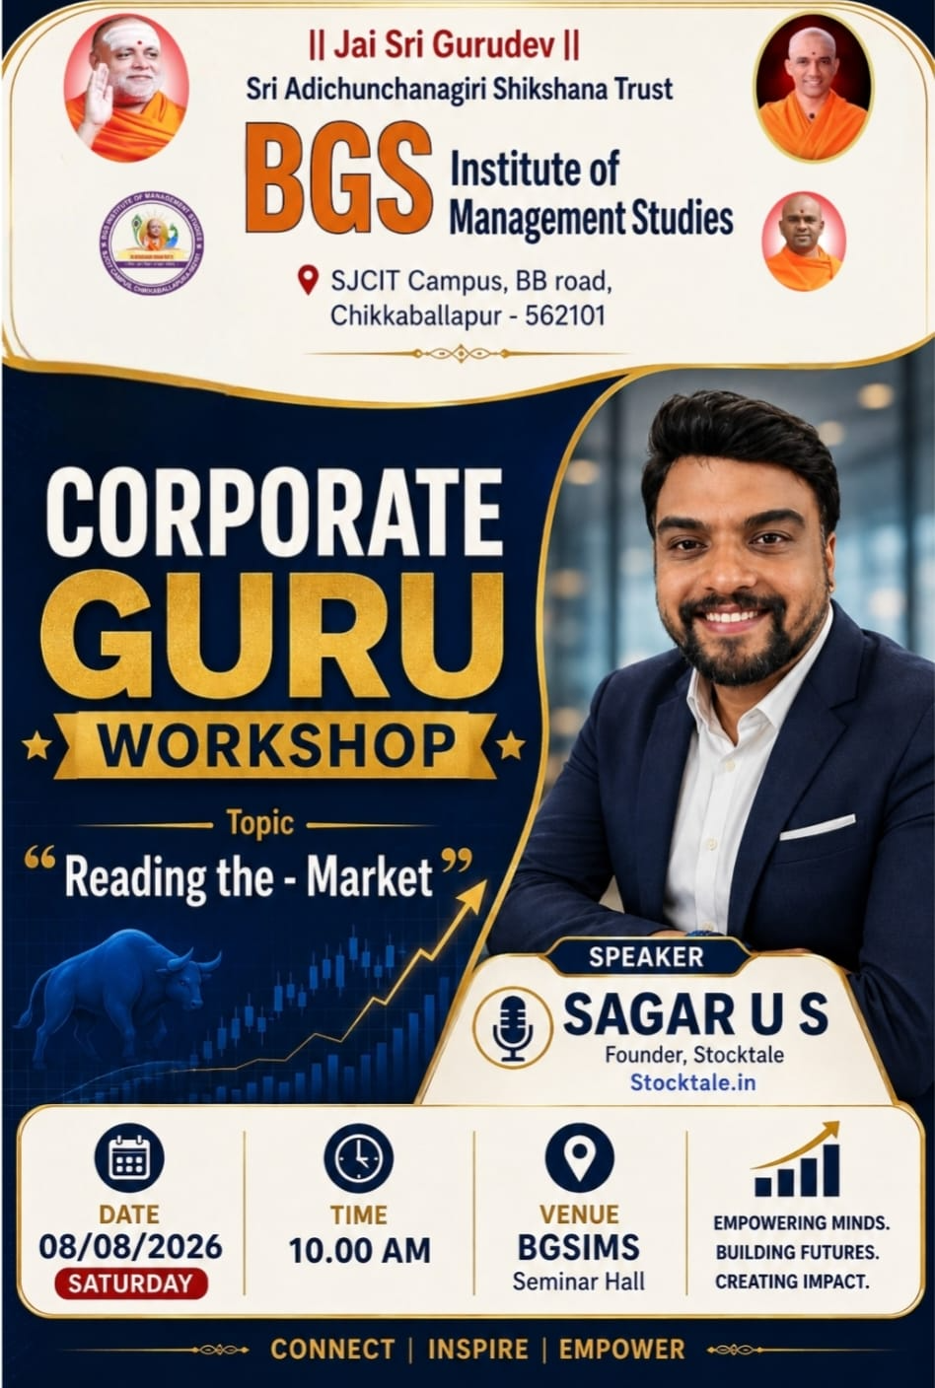

PHOTOGRAPHS:
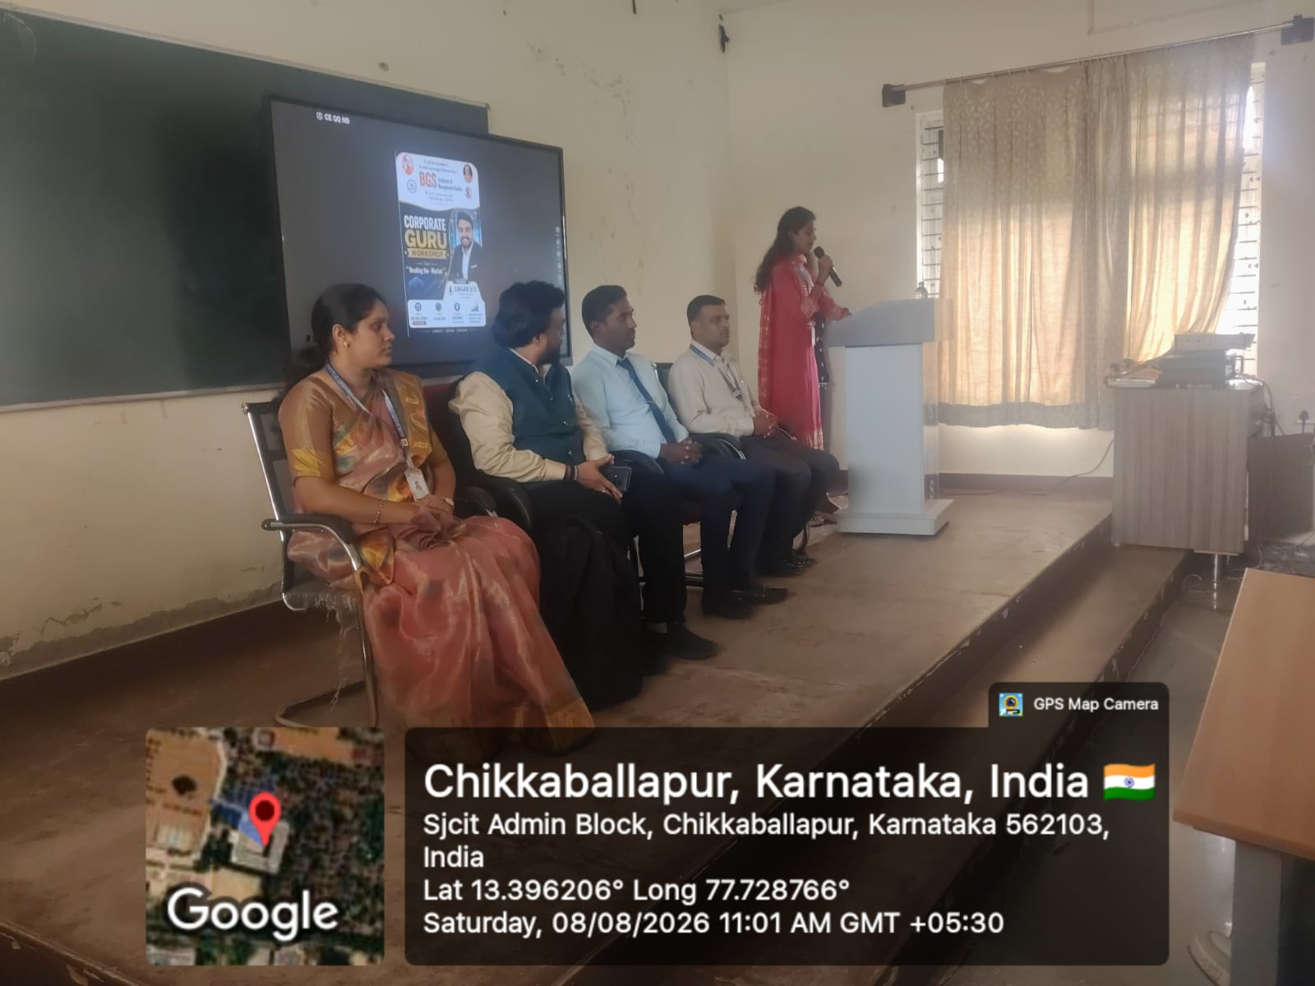  Inaugural session and welcome | 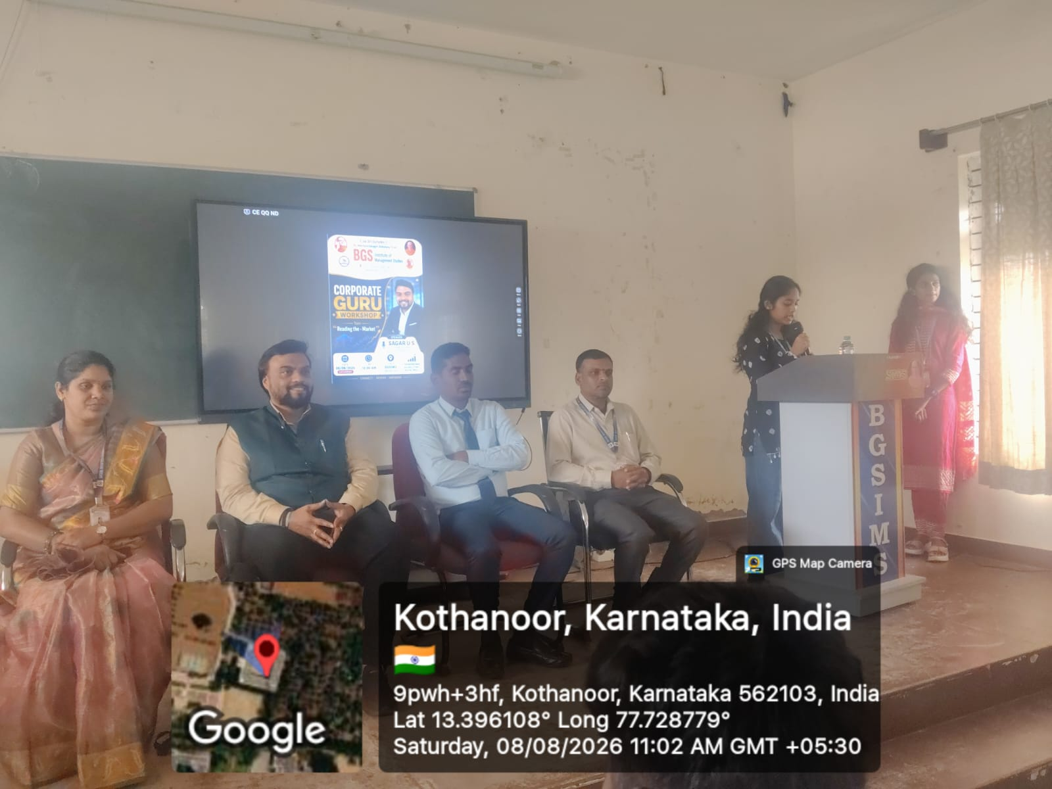  Interaction with the resource person
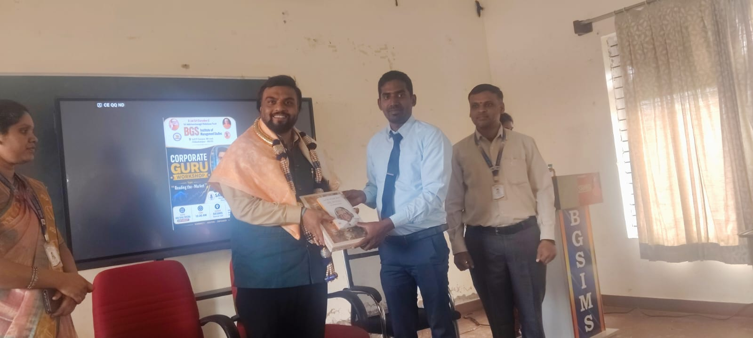  Felicitation of the resource person | 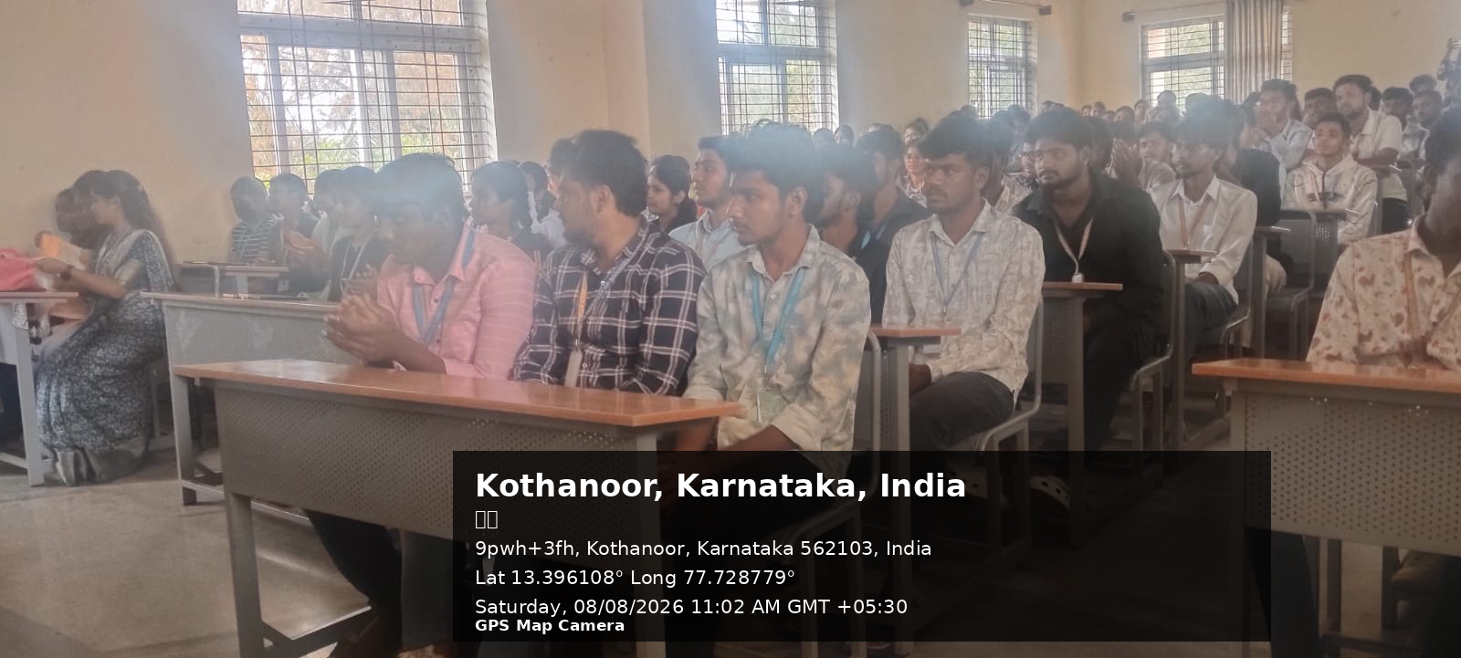  Resource person addressing the gathering
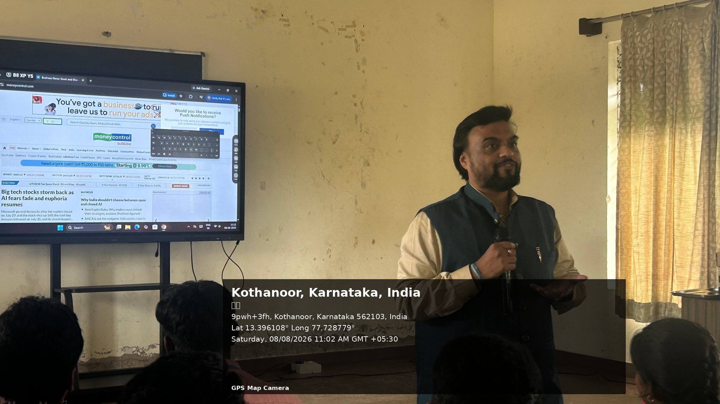  Students participating in the workshop | 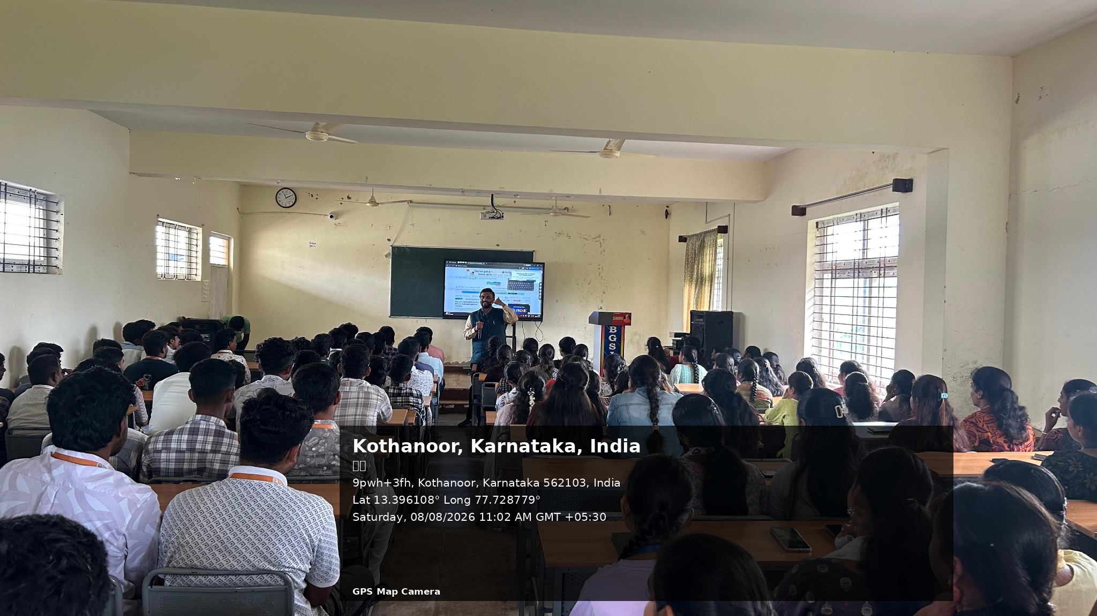  Interactive session on reading the market

CONCLUSION:
The Corporate Guru Workshop on “Reading the Market” was a valuable and informative academic activity. The programme provided the students with practical exposure to financial-market concepts and encouraged them to develop financial literacy, analytical skills and responsible investment awareness. The active participation of students and faculty members contributed to the success of the programme.

Coordinator Academic Administrator Principal

