|| JAI SRI GURUDEV ||
Sri Adichunchanagiri Shikshana Trust ®
B.G.S INSTITUTE OF MANAGEMENT STUDIES SJCIT campus,
Chickballapur – 562101

REPORT ON ALUMNI TALK – “GRAD BOOSTER”
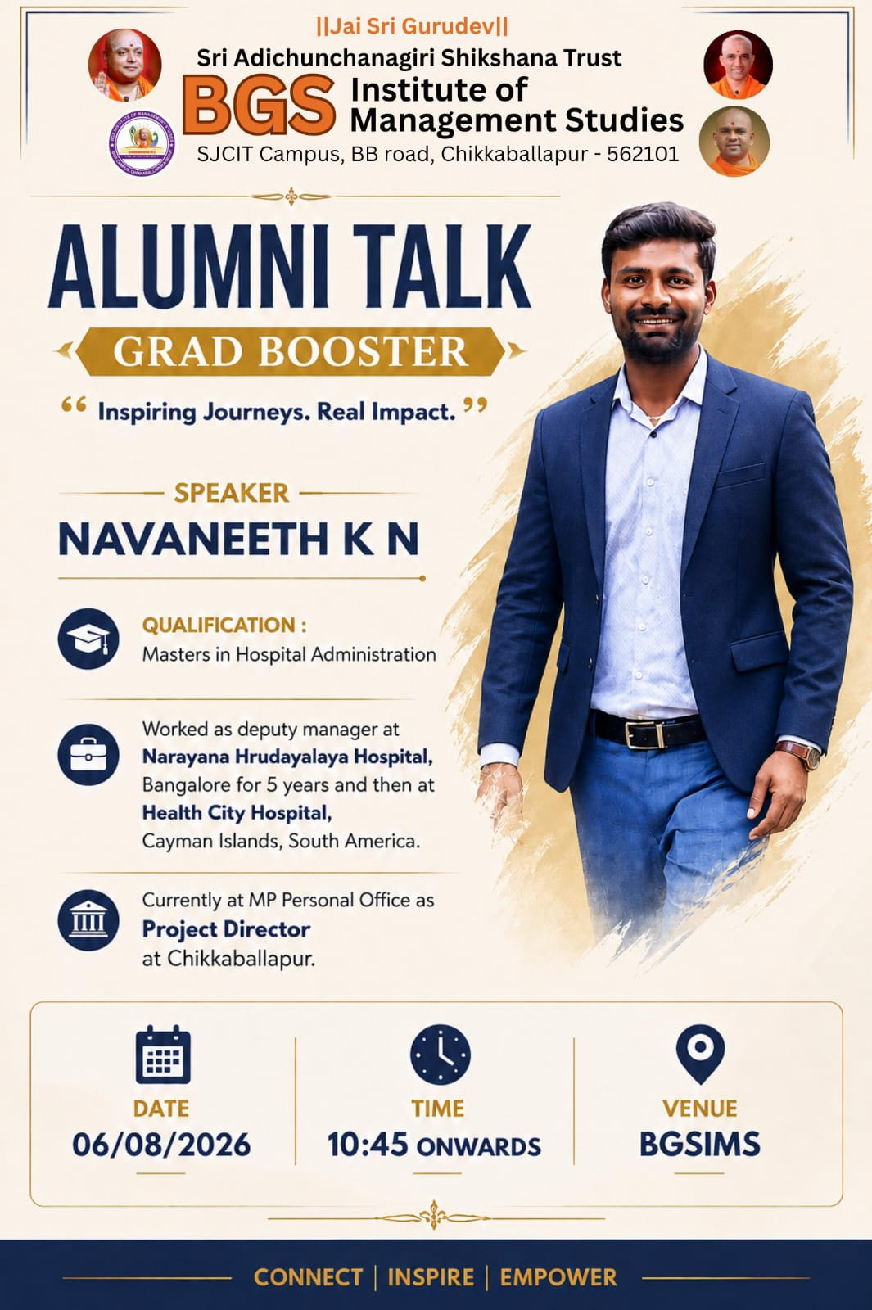

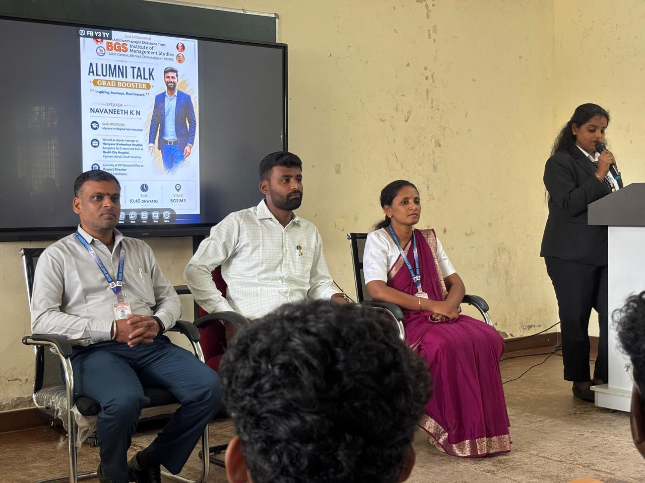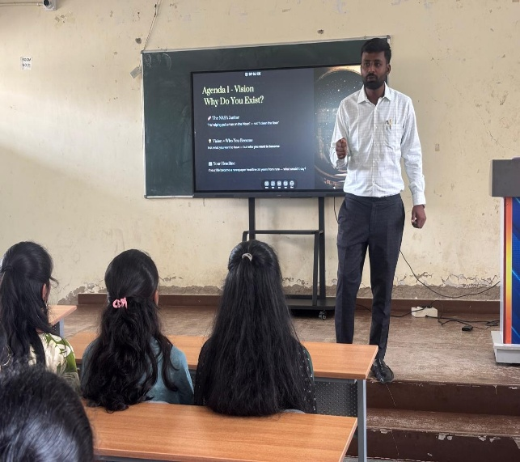
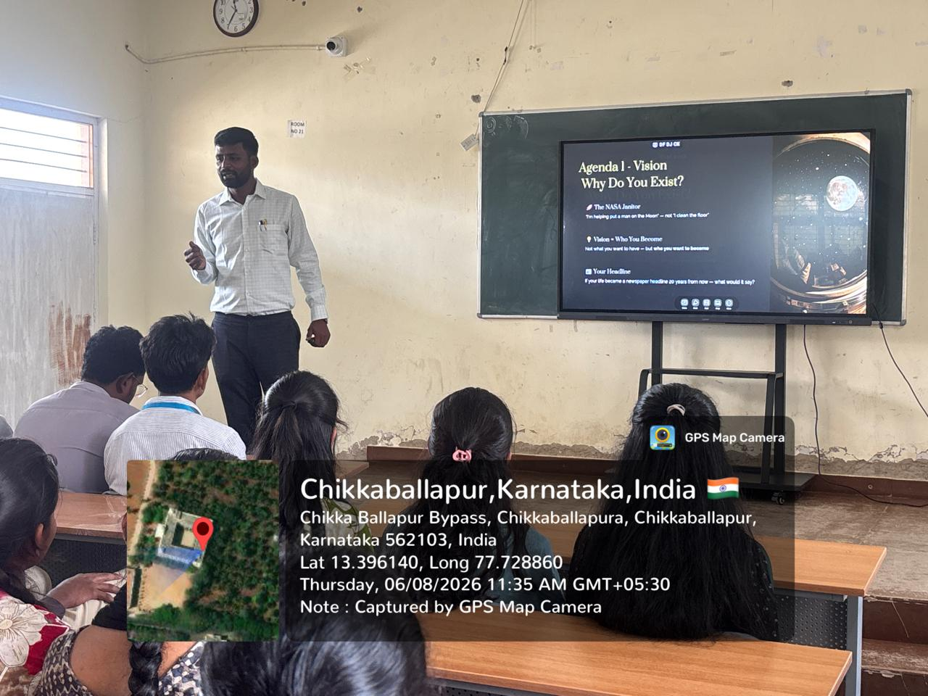

BGS Institute of Management Studies, SJCIT Campus, BB Road, Chikkaballapur, organized an Alumni Talk – “Grad Booster” on 06 August 2026 at 10:45 AM onwards at BGS Institute of Management Studies. The programme was organized with the theme “Inspiring Journeys. Real Impact.” The session aimed to provide students with meaningful insights into professional life, personal development, leadership, and career growth through the experiences of an accomplished alumnus.
The resource person for the programme was Mr. Navaneeth K N, who holds a Master’s degree in Hospital Administration. He has significant professional experience in the healthcare and project management sectors. He worked as a Deputy Manager at Narayana Hrudayalaya Hospital, Bangalore, for five years, and subsequently worked at Health City Hospital, Cayman Islands, South America. He is currently serving as a Project Director at MP Personal Office, Chikkaballapur. His professional journey provided students with practical insights into career development, leadership, adaptability, and personal growth.
The session was based on the theme “The CEO Within”, which encouraged students to understand that leadership begins with taking responsibility for one's own life. The presentation focused on seven important principles: Vision, Yourself, Discipline, Utilization, Resilience, Yes to Learning, and Action. These principles were presented as essential elements for developing a purposeful and successful personal and professional life.
Vision – “Why Do You Exist?” Students were encouraged to develop a clear vision for their future and understand the larger purpose behind their goals. The example of the NASA janitor was used to explain how individuals can connect their everyday responsibilities with a greater purpose. The session emphasized that vision is not simply about what a person wants to have, but about who they want to become. Students were also encouraged to imagine what they would like their life story or future achievements to represent.
Yourself – “Your Culture Begins with You,” focused on personal character, values, integrity, and discipline. Students were encouraged to reflect on their behaviour and ask themselves whether people around them would become better individuals through their influence. The session emphasized that personal culture is created through everyday choices and that people often learn more from an individual's actions and behaviour than from their words.
Discipline – “Your Operations Department.” The speaker highlighted the importance of developing systems and consistent habits rather than depending entirely on motivation or willpower. Students were encouraged to identify areas where their processes could be improved. The example of Virat Kohli was discussed to demonstrate that achievements are the result of years of disciplined training, practice, preparation, and commitment. The session also introduced the concept of neuroplasticity and explained how repeated habits can strengthen behavioural pathways.
Utilization – “How You Use What You Have,” focused primarily on the effective use of time and attention. Students were reminded that every individual has the same 24 hours in a day, but the way those hours are utilized can significantly influence personal and professional outcomes. The session also addressed the impact of the modern attention economy, particularly notifications, reels, and continuous scrolling, which can affect an individual's ability to focus and use time productively.
Resilience – “The Strength to Never Stop.” The speaker explained that setbacks, criticism, and failures are part of personal and professional growth. The example of M. S. Dhoni was used to demonstrate the importance of remaining determined despite challenges and setbacks. Students were encouraged to view failures as learning experiences and to ask what a particular setback could teach them instead of allowing it to negatively define their future.
Yes to Learning – “Never Stop Learning,” emphasized the importance of continuous learning and adaptability. The session highlighted that the professional world is constantly changing and that individuals must continue to develop their knowledge and skills. The example of Netflix and Nokia was used to illustrate the importance of reinvention and adaptation. Students were encouraged to remain lifelong learners and to develop the ability to respond positively to changing circumstances.
Action focused on converting dreams and aspirations into meaningful steps. The speaker used the examples of Hanuman's Leap and Dr. A. P. J. Abdul Kalam's vision to motivate students to recognize their abilities and take purposeful action. The session emphasized that having dreams and goals is not sufficient unless they are supported by consistent action and commitment.
Towards the end of the session, the seven principles—Vision, Yourself, Discipline, Utilization, Resilience, Yes to Learning, and Action—were brought together as a framework for personal leadership. Students were encouraged to select one principle that resonated most deeply with them, identify one specific action related to that principle, and begin implementing it within 24 hours. This approach encouraged students to translate the ideas discussed during the session into practical steps in their personal and professional lives.
The Alumni Talk served as a valuable platform for students to learn from an alumnus's professional journey while reflecting on their own goals, habits, values, and aspirations. The session provided practical perspectives on developing vision, maintaining discipline, utilizing time effectively, overcoming setbacks, embracing continuous learning, and taking action. Through the “The CEO Within” theme, students were encouraged to take ownership of their personal development and recognize themselves as the leaders responsible for shaping their own future.

ALUMNI TALK  CO-ORDINATOR | IQAC  COORDINATOR | PRINCIPAL

