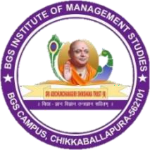
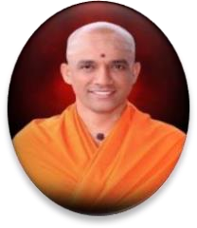
||Jai Sri Gurudev||
Sri Adichunchanagiri Shikshana Trust ®

BGS INSTITUTE OF MANAGEMENT STUDIES
SJCIT Campus, B.B Road, Chikkballapur – 562101

Pre-Meeting Report
International Day Against Trafficking in Persons Theme: "Trapped Behind the Scam"
Date of Pre-Meeting: 29-07-2026
Organized by: Student Development Cell, BGS Institute of Management Studies, Chikkaballapur
Introduction
A pre-meeting was conducted by the Student Development Cell on 29 July 2026 to review and finalize the arrangements for the observance of International Day Against Trafficking in Persons, scheduled on 30 July 2026 at 9:30 AM in the Aeronautical Conference Hall. The meeting focused on assigning responsibilities, coordinating logistics, and ensuring the smooth conduct of the programme.
- Agenda of the Meeting
- Finalization of programme schedule
- Allocation of responsibilities to faculty members
- Stage and seating arrangements
- Guest hospitality and protocol
- Photography and sound system arrangements
- Student discipline and class management
- Media coverage and programme documentation

Responsibilities Assigned
Class In-charge Responsibilities 1st BBA STAR 1 – Kavitha
1st BBA STAR 2 – Mithun 1st B. Com STAR 1 – Akhila
1st B. Com STAR 2 – Pavithra Cleaning and Venue Readiness – Harish Conclusion
The meeting concluded with instructions to complete all assigned responsibilities before the programme. Faculty members and staff assured their cooperation to ensure the successful conduct of the event.

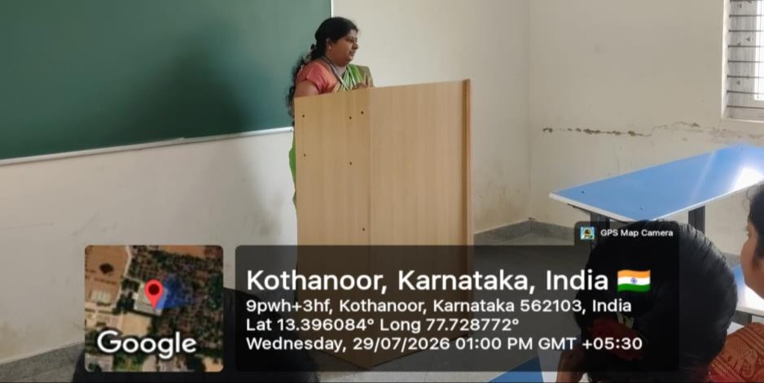

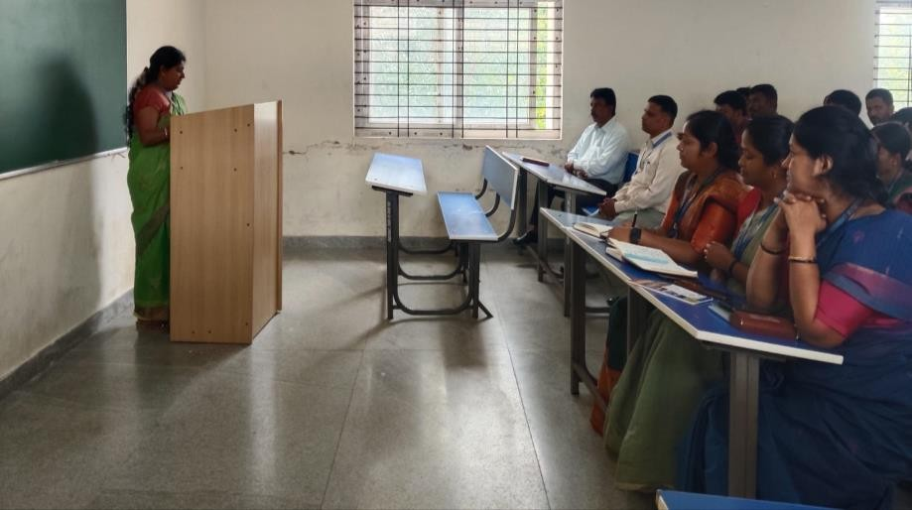

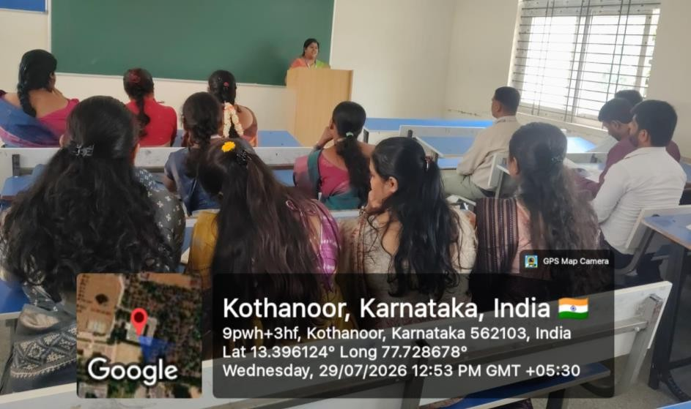

Programme Report on International Day Against Trafficking in Persons

Objective of the Programme
The programme was organized to commemorate the International Day Against Trafficking in Persons with the objective of creating awareness among students regarding human trafficking, cyber-enabled trafficking, online scams, child protection, legal safeguards, and the collective responsibility of society in preventing exploitation.
The programme also aimed to educate students on the following key areas:
- Human trafficking and its various forms across national and international borders.
- Online scams, financial frauds, and cyber exploitation targeting youth.
- Child rights and legal protection mechanisms under Indian legislation.
- Prevention of child marriage and social malpractices.
- Drug abuse, substance addiction, and its psychological/social impact.
- Role of law enforcement agencies and legal institutions in protecting vulnerable sections of society.

Inaugural Session
The programme commenced at 9:30 AM with the dignified presence of eminent guests from the Judiciary, Police Department, Legal Services Authority, Advocate Association, and Child Protection Department.
The ceremonial inauguration was led by our esteemed Chief Guest:
Sri Ramalinge Gowda T.P. — Principal District & Sessions Judge and Chairman, District Legal Services Authority, Chikkaballapur.
In his inaugural address, Sri Ramalinge Gowda T.P. emphasized that human trafficking is one of the fastest-growing organized crimes across the world. He highlighted the importance of awareness, timely reporting, and community participation in combating trafficking. Furthermore, he urged students to become responsible citizens by remaining vigilant against fraudulent employment offers, cyber crimes, and social exploitation.
Presidential Address
Presided over by: Mr. Manjunatha N, Principal, BGS Institute of Management Studies, Chikkaballapur.
In his presidential remarks, Principal Mr. Manjunatha N welcomed all the dignitaries and participants. He emphasized that educational institutions play a significant role in creating social awareness. He encouraged students to utilize such awareness programmes to become socially responsible individuals and to spread awareness within their families and communities.

Chief Guests & Dignitaries
The programme was graced and addressed by the following distinguished guests:

- Smt. Shilpa B — Senior Civil Judge & Member Secretary, District Legal Services Authority, Chikkaballapur.
- Sri Jagannath Rai — Additional Superintendent of Police, Chikkaballapur.
- Sri K. V. Abhilash — President, Bar Association, Chikkaballapur.
- Smt. Nautaj B — District Child Protection Officer, District Child Protection Unit, Chikkaballapur.
- Sri Venkatesh T. M. — Secretary, Bar Association, Chikkaballapur.
Each dignitary highlighted the increasing challenges faced by society due to trafficking, cyber fraud, exploitation of women and children, and the critical need for legal awareness among young citizens. They also stressed the importance of reporting suspicious activities and supporting victims through proper legal channels.

Resource Sessions
Session I: POCSO Act and Child Marriage Prohibition Act
Resource Person: Mr. Ramegowda D. K. — Legal-cum-Probation Officer, District Child Protection Unit, Women and Child Development Department, Chikkaballapur.
The resource person delivered a comprehensive technical session covering:
- Introduction to the Protection of Children from Sexual Offences (POCSO) Act and its salient features.
- Fundamental rights of children guaranteed under Indian law.
- Identification of different forms of child abuse and neglect.
- Institutional responsibilities and mandatory reporting procedures under the POCSO Act.
- Legal consequences, penalties, and societal impact of child marriage.
- Overview of government initiatives and welfare schemes for child protection.
- Crucial role of teachers, parents, and students in safeguarding minors.
Students actively interacted during the session, raising pertinent questions regarding legal procedures, confidential reporting mechanisms, and preventive community measures.
Session II: Against Drug Abuse
Resource Person: Mr. Sadiq Pasha — Counsellor, Sri Sai IRCA, Bangalore Rural.
The second technical session focused intensively on creating awareness about substance abuse and addiction among youth.
- Major points discussed during the session included:
- Root causes of drug addiction and experimental substance use among adolescents.
- Psychological, behavioral, and social impacts of substance abuse.
- Severe health consequences associated with narcotic consumption.
- Navigating peer pressure and implementing effective preventive strategies.
- Importance of empathetic counselling, professional treatment, and rehabilitation.
- Proactive role of educational institutions in preventing drug abuse on campuses.

- The speaker motivated students to adopt healthy lifestyles, avoid harmful peer influences, and seek professional guidance whenever necessary.

Highlights of the Programme
Commemoration of the International Day Against Trafficking in Persons under the theme “Trapped Behind the Scam”.
- In-depth legal awareness regarding human trafficking syndicates and modus operandi.
- Comprehensive information on cyber scams, digital frauds, and online exploitation.
- Detailed orientation on the POCSO Act and child rights.
- Exhaustive explanation of the Child Marriage Prohibition Act.
- Substance abuse prevention and de-addiction counselling insights.
- Highly engaging interactive Q&A sessions between students and domain experts.
- Multi-agency collaboration uniting the Judiciary, Police Department, Legal Services Authority, Child Protection Unit, and Academia.

Student Participation
The programme witnessed enthusiastic participation from students, faculty members, and administrative staff of the BGS Institute of Management Studies. Students actively interacted with the resource persons during the question-and-answer sessions, gaining practical knowledge regarding:
- Personal safety protocols and situational awareness.
- Digital hygiene and cyber security best practices.
- Fundamental legal rights and constitutional safeguards.
- Child protection laws and emergency helpline numbers.
- Effective reporting mechanisms for suspicious activities.
The programme significantly enhanced students’ awareness regarding social responsibility and legal literacy.

Outcome of the Programme:
The programme successfully achieved its intended objectives. Key participant outcomes included:
A profound understanding of human trafficking, its grim realities, and societal consequences. Heightened alertness regarding cyber-enabled trafficking and modern online financial scams. Sound working knowledge of legal provisions under the POCSO Act. Clear awareness of anti-child marriage legislation and enforcement. Greater consciousness regarding the destructive physical and mental effects of drug abuse. Increased confidence in approaching legal authorities, police, and child protection agencies for assistance. A renewed commitment to promote social awareness and safeguard vulnerable individuals in the community.
Overall, the event substantially strengthened coordination between educational institutions, legal authorities, police departments, and child protection agencies in fostering a safer, more informed society.

Conclusion
The programme concluded with a formal vote of thanks expressing deep gratitude to the distinguished judiciary dignitaries, resource persons, District Legal Services Authority, Police Department, Advocate Association, District Child Protection Unit, institutional management, Principal, faculty members, Student Development Cell, and all student participants for making the event highly informative and successful.
The programme served as an exceptional platform to educate students on human trafficking, legal rights, child protection, cyber safety, and drug abuse prevention, thereby contributing significantly to the holistic development of socially responsible and legally aware citizens.

Annexures:
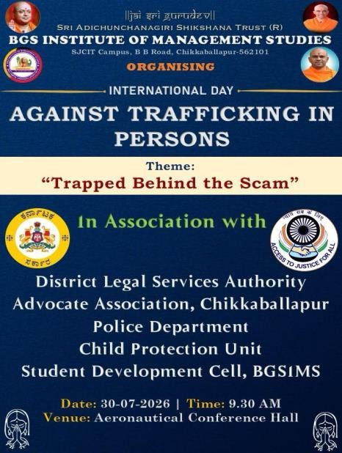
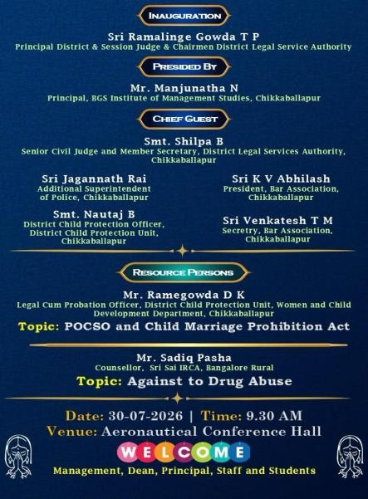
Fig: Invitation of the Programme

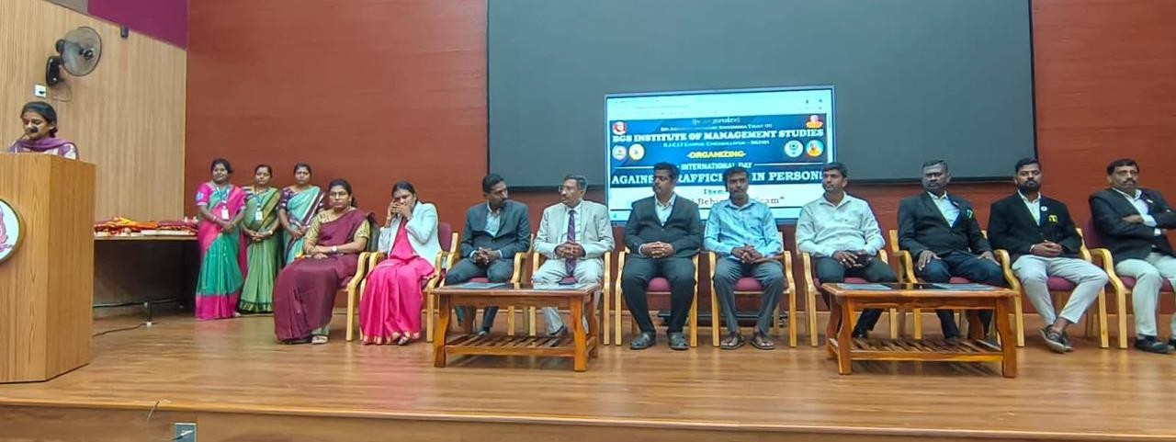
Photographs

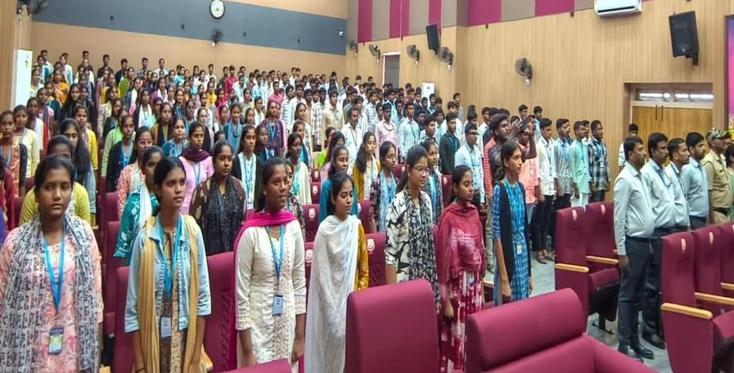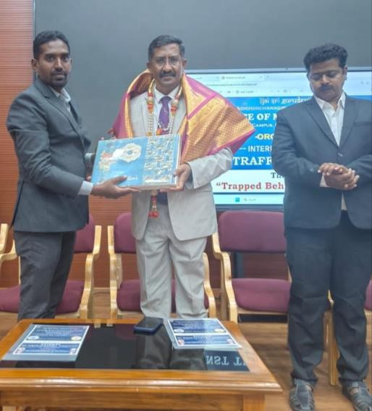
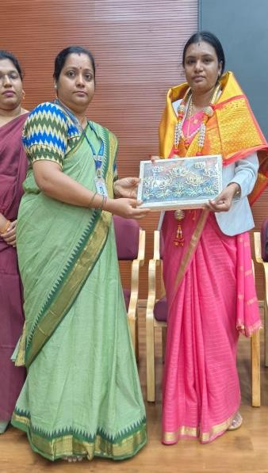
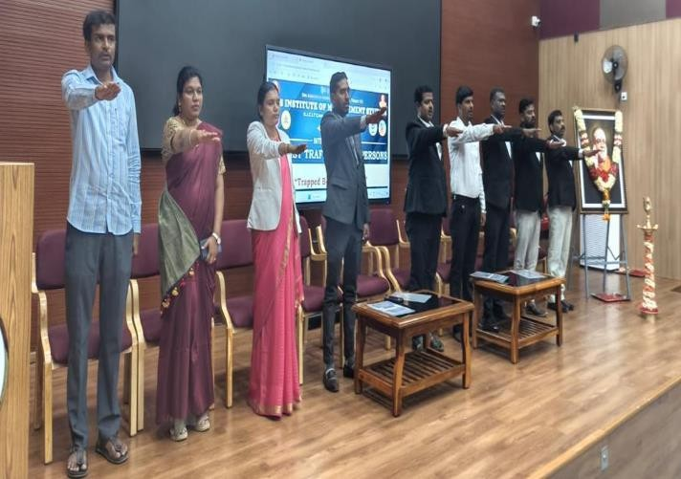
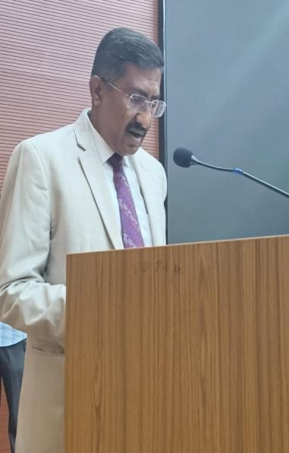

News Paper Cutting:
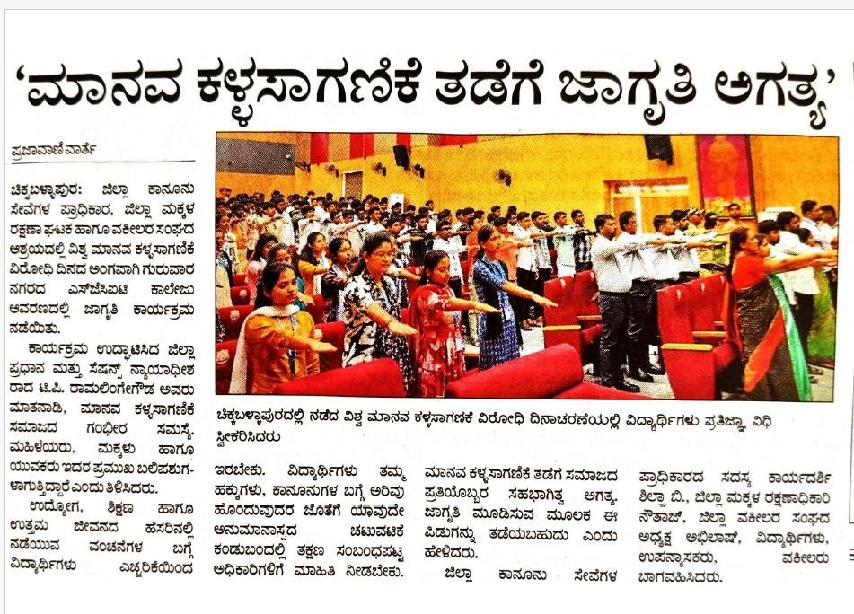

Post-Meeting Report:
Following the successful conduct of the programme, a post-meeting was held under the guidance of the Programme Coordinator and the Principal to review the overall execution of the event. The Programme Coordinator presented the programme outcomes, participant engagement, and documentation status, while the Principal appreciated the coordinated efforts of the organizing committee, faculty members, and students. The meeting concluded that the programme effectively achieved its objectives of creating awareness on human trafficking, cyber safety, child protection, and drug abuse prevention. It was also recommended to organize similar awareness programmes in the future to strengthen students' legal literacy and social responsibility.

Report Prepared by:

Mithun S Assistant Professor

Program IQAC Principal Co-Ordinator Co-Ordinator

