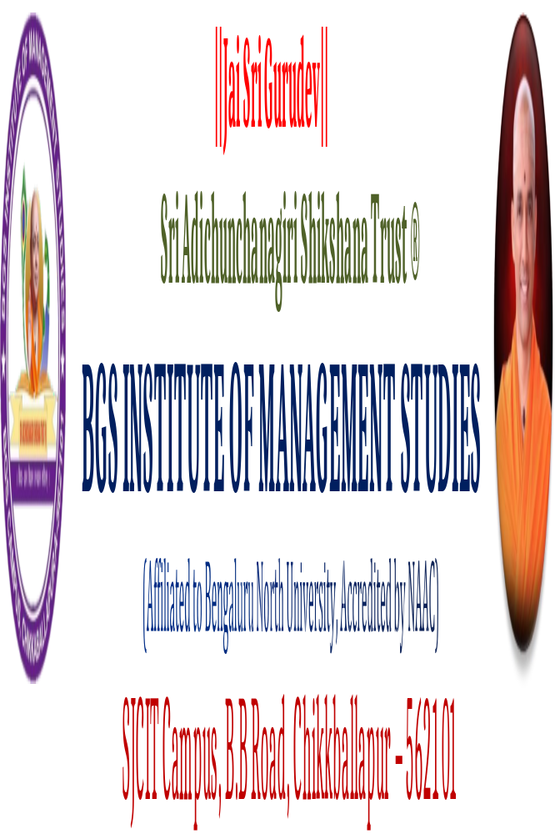

Report on the Formal Welcome Programme, Introduction about the Mutt and Institution
Student Induction Programme for the First-Year Students (Academic year 2026-27) BY MR. Manjunath N., Principal BGSIMS ( 21-7-2026, 9:15 TO 11 AM)
Introduction
A Formal Welcome Programme was organized for the newly admitted students with the objective of providing them with a warm and meaningful introduction to the institution, its academic environment, values, traditions, and student-support facilities. The programme was designed to help students feel comfortable in their new academic setting and to create a positive beginning to their higher education journey.
The programme commenced with a formal introduction to the Mutt and its educational vision, highlighting its contribution towards the promotion of education, discipline, values, culture, and holistic development of students. The students were made aware of the institution's commitment to providing quality education along with opportunities for personality development, leadership, professional skills, and ethical values.
Mr. Manjunatha N., Principal, addressed the gathering and formally introduced the students to the institution. In his address, he explained the vision, mission, objectives, academic practices, institutional culture, and expectations from students. He emphasized the importance of discipline, regular attendance, academic commitment, effective communication, active participation in co-curricular and extracurricular activities, and responsible behaviour within the campus.
The Principal also encouraged students to make effective use of the academic and infrastructural facilities available in the institution. He highlighted the importance of developing employability skills, critical thinking, teamwork, leadership qualities, and a positive attitude alongside academic knowledge. Students were encouraged to actively participate in seminars, workshops, clubs, extension activities, projects, internships, and other institutional initiatives.
The programme also provided an opportunity for students to understand the role of various departments and institutional committees in supporting their academic and personal development. The students were briefed about maintaining discipline, following institutional rules and regulations, seeking academic guidance from faculty members, and contributing positively to the institutional environment.

Objectives of the Programme
- To formally welcome newly admitted students to the institution.
- To introduce students to the vision, mission, values, and educational philosophy of the institution.
- To familiarize students with the institutional facilities, academic practices, and student-support systems
- To create awareness about discipline, attendance, academic responsibilities, and institutional expectations.
- To motivate students towards holistic development and active participation in academic and co-curricular activities.
- To establish a positive relationship between students, faculty members, and the institution.

Outcome of the Programme

The Formal Welcome Programme created a positive and welcoming environment for the newly admitted students. Students gained a clear understanding of the institution's vision, values, academic expectations, rules, facilities, and opportunities available for their overall development. The interaction with the Principal helped students understand the importance of discipline, commitment, participation, and professional development.

The programme successfully contributed towards student induction, orientation, institutional familiarization, and value-based education, thereby providing a strong foundation for students to begin their academic journey with confidence and responsibility.

ANNEXURE
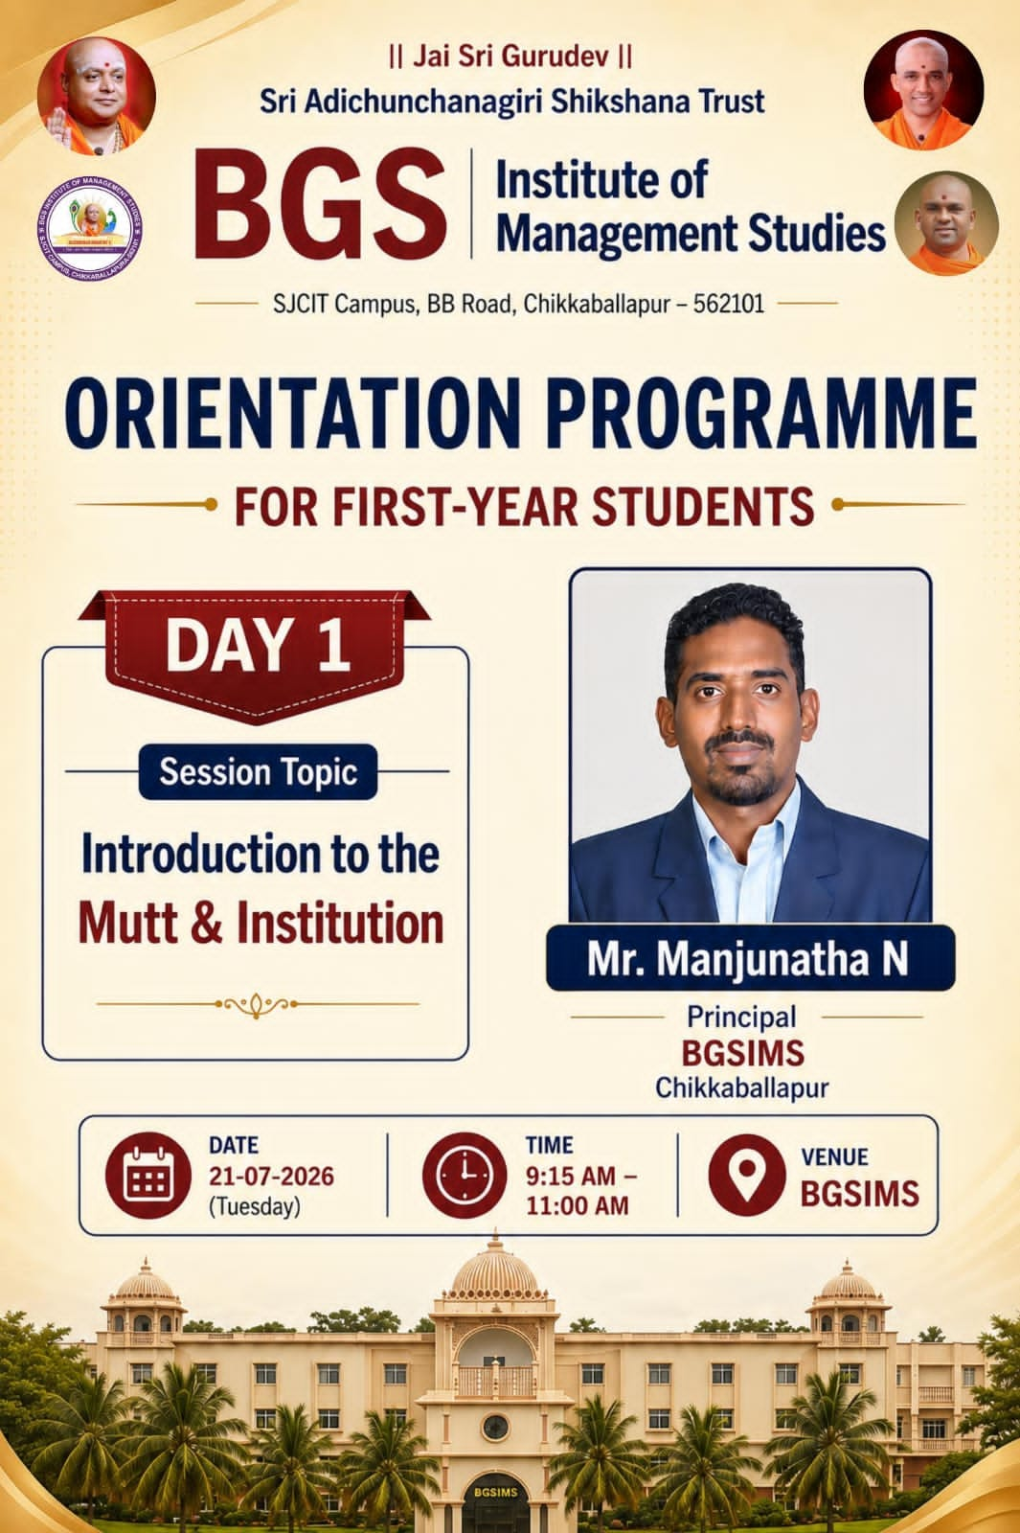

REPORT ON CODE OF CONDUCT AND CALENDAR OF EVENTS
Student Induction Programme for the First-Year Students (Academic year 2026-27) BY MR. RAVICHANDRA R., Academic administrator BGSIMS ( 21-7-2026, 11:15 TO 12:45 pm)

Introduction
As part of the student orientation and induction programme, a session on “Code of Conduct and Calendar of Events” was organized to familiarize students with the rules, regulations, academic expectations, institutional practices, and important activities planned for the academic year. The session was conducted by Mr. Ravichandra R, who provided students with systematic guidance regarding responsible behaviour and active participation in institutional activities.

Code of Conduct
Mr. Ravichandra R explained the importance of maintaining discipline and professional conduct within the institution. Students were sensitized to the responsibilities expected of them as members of the academic community.
The session highlighted important aspects such as:
- Maintaining regular attendance and punctuality.
- Adhering to institutional rules and regulations.
- Maintaining discipline and respectful behaviour towards faculty members, staff, and fellow students.
- Wearing appropriate dress and maintaining professional decorum.
- Taking care of institutional property and maintaining campus cleanliness.
- Following academic integrity and avoiding plagiarism or any form of malpractice.
- Using digital resources and social media responsibly.
- Maintaining appropriate behaviour during academic, cultural, sports, and extension activities.
- Actively participating in institutional programmes and student-development initiatives.
- Following safety, security, and other institutional guidelines.
Students were encouraged to understand that the Code of Conduct is not merely a set of restrictions but a framework for developing discipline, responsibility, ethical behaviour, professionalism, and respect for others.

Calendar of Events
The students were also introduced to the Calendar of Events of the institution. The importance of the academic calendar in planning and participating in institutional activities was explained.
The calendar provides information regarding:
- Commencement and completion of academic activities.
- Internal assessments and examinations.
- Seminars, workshops, guest lectures, and conferences.
- Co-curricular and extracurricular activities.
- Student clubs and association activities.
- Cultural and sports programmes.
- Extension and outreach activities.
- Skill-development and career-oriented programmes.
- Institutional celebrations and important observances.
- Holidays and other significant academic events.
Students were encouraged to regularly follow the institutional calendar and plan their academic and extracurricular commitments accordingly.

Conclusion
The session on “Code of Conduct and Calendar of Events”, conducted by Mr. Ravichandra R, provided students with essential information regarding institutional discipline, academic responsibilities, ethical practices, and planned institutional activities. The programme contributed significantly to creating awareness among students about their responsibilities and opportunities within the institution.

ANNEXURE
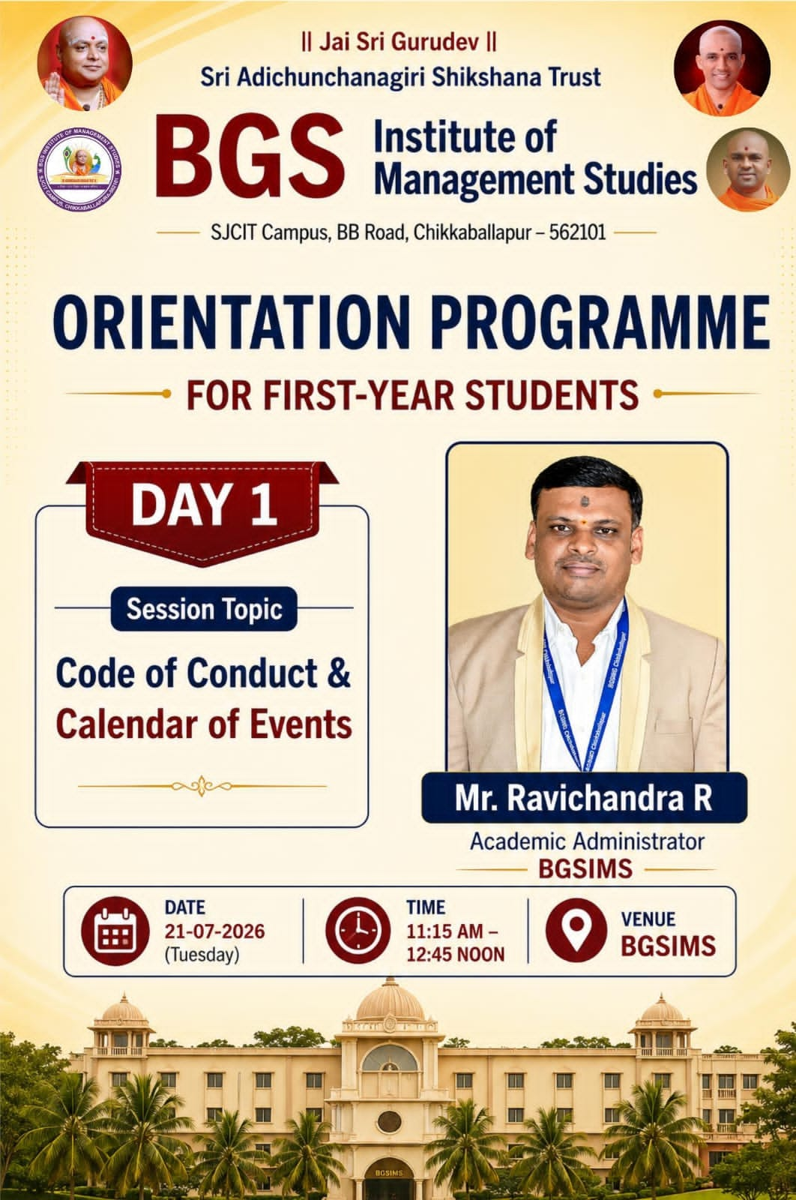

Prepared by IQAC coordinator

Pavithra V Mr. Ravichandra R

REPORT ON “KNOW YOUR COURSE & GOAL”

Student Induction Programme for the First-Year Students (Academic year 2026-27)
BY MR, AVINASH. ON 22-7-2026 (1-30 TO 2:45)

Introduction
As part of the student induction and orientation programme, a session on “Know Your Course & Goal” was organized to help students understand the academic structure, scope, career opportunities, and learning outcomes associated with their chosen programme. The session was conducted by Mr. Avinash, who provided students with valuable guidance on understanding their course and setting meaningful academic and career goals.

Objectives of the Session
- The session was organized with the following objectives:
- To familiarize students with the structure and objectives of their chosen course.
- To create awareness about the subjects, curriculum, and learning opportunities offered during the programme.
- To help students understand the relevance of their course to higher education and career opportunities.
- To encourage students to identify their interests, strengths, and areas for improvement.
- To develop the habit of setting clear, realistic, and achievable goals.
- To motivate students to plan their academic and professional journey systematically.

Session Proceedings

Mr. Avinash explained that understanding one's course is the first step towards making effective academic and career decisions. Students were introduced to the overall structure of their programme and were encouraged to understand the purpose and practical relevance of the subjects included in the curriculum.
The session emphasized that students should not limit their learning to classroom teaching alone. They were encouraged to develop additional competencies through seminars, workshops, internships, projects, certifications, presentations, group discussions, industrial visits, and other experiential learning activities.
The importance of identifying a clear goal at the beginning of the academic journey was also highlighted. Students were encouraged to reflect on their interests, abilities, career aspirations, and personal strengths while deciding their short-term and long-term goals.

Goal Setting and Career Planning
The students were guided on the importance of setting SMART goals—Specific, Measurable, Achievable, Relevant, and Time-bound. It was explained that a clear goal provides direction and motivation and helps students monitor their progress.Students were encouraged to divide their long-term career goals into smaller achievable milestones. For example, a student aspiring to pursue a career in banking or finance can focus on developing academic knowledge, communication skills, computer skills, financial awareness, aptitude, leadership qualities, and relevant professional competencies throughout the course. The session also emphasized the importance of regularly reviewing one's progress and modifying goals whenever necessary based on changing interests, opportunities, and professional requirements.

Formal Explanation
The “Know Your Course & Goal” session aimed to create a clear connection between academic learning and future career aspirations. Students were encouraged to understand what they are studying, why they are studying it, and how the knowledge and skills gained through the course can contribute to their future career and personal development.
The session helped students recognize that higher education is not merely about obtaining a degree but also about developing knowledge, skills, values, confidence, professional competence, and lifelong learning abilities.

Outcomes of the Session

At the end of the session, students were able to:
- Understand the structure and relevance of their chosen course.
- Recognize the importance of curriculum-based and experiential learning.
- Identify their academic interests and career aspirations.
- Understand the importance of short-term and long-term goal setting.
- Develop a basic framework for academic and career planning.
- Recognize the importance of skill development and continuous learning.
- Become more confident and purposeful about their academic journey.

Conclusion
The “Know Your Course & Goal” session conducted by Mr. Avinash was informative and beneficial in helping students understand the relevance of their chosen programme and the importance of establishing clear academic and career goals. The session encouraged students to take ownership of their learning, develop relevant competencies, and plan their future systematically.
Overall, the programme contributed to student orientation, academic awareness, goal setting, career readiness, skill development, and holistic student development, thereby supporting the institution's commitment to quality education and continuous improvement

ANNEXURE

“REPORT ON “HOW TO PLAN YOUR NEXT FIVE YEARS”

Student Induction Programme for the First-Year Students (Academic year 2026-27) BY MRS, ASHWINI B ON 22-7-2026 (2:45TO 2:45)

Introduction

As part of the student induction and orientation programme, a session on “How to Plan Your Next Five Years” was organized to help students develop a clear vision for their academic, personal, and professional growth. The session was conducted by Smt. Ashwini N who guided the students on the importance of long-term planning, goal setting, self-development, and career preparedness. The session aimed to encourage students to look beyond their immediate academic responsibilities and develop a structured five-year roadmap that would help them progress towards their desired career and personal aspirations.

Objectives of the Session

The session was organized with the following objectives:
- To create awareness about the importance of long-term planning.
- To help students identify their academic and career aspirations.
- To encourage students to set short-term, medium-term, and long-term goals.
- To develop a systematic five-year action plan.
- To motivate students to acquire relevant skills and competencies.
- To encourage students to regularly evaluate their progress and make necessary improvements.
- To develop confidence, responsibility, and a proactive approach towards career development.

Session Proceedings

Smt. Ashwini explained that the next five years can play a significant role in shaping a student's academic and professional future. Students were encouraged to visualize where they would like to see themselves after five years and then work backwards to identify the steps required to reach that destination. The session emphasized that effective planning should include academic achievement, skill development, career preparation, financial awareness, personal development, communication skills, leadership qualities, and social responsibility.
Students were encouraged to identify their strengths, weaknesses, interests, and areas requiring improvement. They were also advised to remain flexible and update their goals according to changing circumstances, opportunities, and career requirements.

Five-Year Planning Framework
The students were guided to prepare their five-year plan by focusing on the following areas:
1. Academic Development
Students were encouraged to maintain good academic performance, strengthen conceptual knowledge, participate actively in classroom activities, and pursue higher education or professional qualifications according to their career interests.
2. Skill Development
The importance of developing communication, digital, analytical, problem-solving, teamwork, leadership, and presentation skills was emphasized. Students were encouraged to participate in workshops, certifications, internships, projects, and other skill-based learning activities.
3. Career Planning
Students were guided to identify suitable career pathways and understand the qualifications and competencies required for their desired profession. They were encouraged to gain practical exposure and develop employability skills.
4. Personal Development
The session highlighted the importance of self-confidence, time management, discipline, positive attitude, emotional maturity, and continuous self-improvement.
5. Professional Networking
Students were encouraged to build positive professional relationships with faculty members, peers, alumni, industry professionals, and other stakeholders. Networking was presented as an important component of career development.
6. Review and Evaluation
Students were advised to periodically review their progress against their planned goals. They were encouraged to identify achievements, recognize challenges, and modify their action plans whenever required.

Suggested Five-Year Roadmap
Year | Major Focus
Year 1 | Understand the course, build academic foundations, identify interests, and develop basic communication and digital skills.
Year 2 | Strengthen subject knowledge, participate in co-curricular activities, develop professional skills, and explore career options.
Year 3 | Complete internships/projects, develop employability skills, prepare for higher education or placements, and establish career goals.
Year 4 | Pursue advanced qualifications or employment opportunities, strengthen professional competencies, and gain practical experience.
Year 5 | Establish oneself in the chosen career, pursue further professional development, and review long-term career and personal goals.

Formal Explanation
The session emphasized that planning the next five years does not mean predicting every event in advance; rather, it means developing a clear direction and taking consistent steps towards one's aspirations. Students were encouraged to convert their dreams into measurable goals and their goals into practical action plans. The students were also advised to understand that success requires consistency, discipline, adaptability, continuous learning, and a willingness to learn from failures. A five-year plan should therefore be realistic, flexible, and periodically reviewed.

Conclusion

The session on “How to Plan Your Next Five Years”, conducted by Smt. Ashwini, provided students with valuable guidance on setting goals and developing a structured roadmap for their academic, professional, and personal development. The session motivated students to take responsibility for their future and encouraged them to adopt a systematic and proactive approach towards achieving their aspirations.
Overall, the programme served as a valuable student-development and career-readiness initiative, contributing to holistic development, employability enhancement, student progression, and the institution's continuous quality-improvement objectives.

ANNEXURE

Prepared By IQAC Coordinator

Pavithra V Mr. Ravichandra R

REPORT ON “CRITICAL THINKING AND PROBLEM SOLVING”
Student Induction Programme for the First-Year Students (Academic year 2026-27) BY Mr. Anand Kulkarni, StenCorniche, ( 23-7-2026, 9:15 TO 11 AM)

Introduction
As part of the student induction and orientation programme, a session on “Critical Thinking and Problem Solving” was organized to develop students’ ability to analyze situations logically, evaluate information, identify challenges, and arrive at appropriate solutions. The session was conducted by Mr. Anand Kulkarni, Sten Corniche, who provided students with valuable insights into the importance of critical thinking and problem-solving skills in academic, personal, and professional life. The session focused on equipping students with practical approaches to deal with complex situations, make informed decisions, and develop a solution-oriented mindset.

Objectives of the Session
The session was organized with the following objectives:
- To create awareness about the importance of critical thinking and problem-solving skills.
- To develop students’ ability to analyze situations logically and objectively.
- To encourage students to identify the root causes of problems.
- To develop decision-making and analytical skills.
- To encourage students to consider multiple perspectives before reaching conclusions.
- To promote creativity, innovation, and a solution-oriented approach.
- To prepare students to handle academic and real-life challenges effectively.

Session Proceedings
Mr. Anand Kulkarni explained that critical thinking is the ability to analyze, evaluate, interpret, and question information before accepting it as valid, while problem solving involves identifying a problem, understanding its causes, generating possible solutions, and selecting the most appropriate course of action. The students were encouraged to avoid making decisions based solely on assumptions or incomplete information. Instead, they were guided to collect relevant facts, ask appropriate questions, examine different viewpoints, and evaluate the available alternatives. The session emphasized that critical thinking is not about criticizing others but about developing an objective, logical, and evidence-based approach to thinking.

Problem-Solving Process
The students were introduced to a systematic approach to problem solving:
- Identify the Problem

The first step is to clearly understand and define the actual problem rather than addressing only its symptoms.
2. Collect and Analyze Information
Students were encouraged to gather relevant facts and examine the available information carefully before making decisions.
3. Identify the Root Cause
The importance of identifying the underlying cause of a problem was explained. Addressing the root cause helps prevent the problem from recurring.
4. Generate Alternatives
Students were encouraged to think creatively and develop multiple possible solutions instead of immediately selecting the first available option.
5. Evaluate the Alternatives
Each alternative should be evaluated based on its advantages, disadvantages, feasibility, consequences, and available resources.
6. Implement the Solution
The most suitable solution should be implemented systematically with appropriate planning and responsibility.
7. Review the Outcome
Students were encouraged to evaluate whether the solution successfully addressed the problem and to make improvements wherever necessary.

Critical Thinking in Academic and Professional Life
The session highlighted that critical thinking is an essential skill for students in their academic journey. It helps them understand concepts more deeply, analyze case studies, interpret data, question assumptions, and develop independent opinions. In professional life, these skills are useful for decision making, teamwork, leadership, financial analysis, management, customer service, project management, and handling workplace challenges. Students were encouraged to develop the habit of asking “Why?”, “How?”, “What evidence supports this?”, and “What are the possible alternatives?” before reaching conclusions.

Interactive and Practical Learning

The session encouraged students to approach problems through practical examples and real-life situations. Students were motivated to participate actively, express their opinions, listen to different perspectives, and work collaboratively to arrive at solutions.Such activities helped students understand that effective problem solving often requires a combination of logical reasoning, creativity, communication, teamwork, and decision-making skills.

Formal Explanation
Critical thinking and problem solving are important components of 21st-century skills and employability competencies. Academic knowledge alone may not be sufficient to address the complex and dynamic challenges faced in personal and professional environments. Critical thinking enables students to distinguish facts from assumptions, assess the reliability of information, and make reasoned judgments. Problem-solving skills enable them to convert these judgments into practical actions. Therefore, developing these competencies at the undergraduate level can help students become more independent learners, effective decision makers, responsible professionals, and confident individuals.

Outcomes of the Session
At the end of the session, students were able to:
- Understand the meaning and importance of critical thinking.
- Recognize the relationship between critical thinking and problem solving.
- Identify problems systematically and analyze their root causes.
- Evaluate information and alternatives before making decisions.
- Develop logical and evidence-based thinking.
- Generate creative and practical solutions.
- Improve decision-making and analytical abilities.
- Understand the importance of teamwork and multiple perspectives.
- Apply problem-solving approaches to academic and real-life situations.

Conclusion

The session on “Critical Thinking and Problem Solving”, conducted by Mr. Anand Kulkarni, Sten Corniche, was informative and highly relevant to the overall development of students. The session encouraged students to approach challenges logically, question assumptions, analyze available information, and develop practical solutions. Overall, the programme contributed significantly to skill development, analytical thinking, decision-making, creativity, employability, and holistic student development.

REPORT ON “CORPORATE ETIQUETTE”
Student Induction Programme for the First-Year Students (Academic year 2026-27) BY Mr. Anand Kulkarni, StenCorniche, ( 23-7-2026, 11:15 to 12:45pm)

Introduction

As part of the student induction and orientation programme, a session on “Corporate Etiquette” was organized to familiarize students with the professional standards, workplace behaviour, communication practices, and interpersonal skills expected in a corporate environment. The session was conducted by Mr. Anand Kulkarni, who provided students with valuable guidance on developing professional conduct and workplace readiness. The session emphasized that academic knowledge alone is not sufficient for career success. Professional etiquette, communication, discipline, appearance, attitude, and interpersonal skills play an important role in creating a positive professional identity.

Objectives of the Session
The session was organized with the following objectives:
- To create awareness about professional behaviour and workplace etiquette.
- To develop effective verbal and non-verbal communication skills.
- To familiarize students with professional standards expected in corporate organizations.
- To develop confidence, punctuality, discipline, and appropriate workplace behaviour.
- To improve students' interpersonal and networking skills.
- To prepare students for internships, placements, interviews, and professional environments.
- To promote a positive and responsible professional attitude.

Session Proceedings
Mr. Anand Kulkarni explained the meaning and importance of corporate etiquette and highlighted that professional etiquette refers to the accepted standards of behaviour that enable individuals to interact respectfully and effectively in a workplace. Students were guided on how their behaviour, communication style, appearance, attitude, and professional interactions contribute to their personal and organizational image. The session covered various dimensions of corporate etiquette, including professional communication, workplace behaviour, dress and grooming, meeting etiquette, email etiquette, telephone etiquette, time management, teamwork, and digital professionalism.

Major Areas Covered
1. Professional Communication
Students were encouraged to communicate clearly, politely, and confidently with colleagues, seniors, clients, and other stakeholders. The importance of appropriate language, active listening, appropriate tone, and respectful communication was emphasized.
2. Dress and Grooming
The importance of maintaining a neat, clean, and professional appearance was explained. Students were advised to understand the dress expectations of different professional environments and maintain appropriate personal grooming.
3. Punctuality and Time Management
The session emphasized that punctuality reflects professionalism and respect for others' time. Students were encouraged to develop effective time-management habits and complete assigned responsibilities within deadlines.
4. Meeting Etiquette
Students were introduced to appropriate behaviour during formal meetings, presentations, and discussions. They were advised to arrive on time, listen attentively, participate constructively, avoid unnecessary interruptions, and maintain professional decorum.
5. Email and Digital Etiquette
The importance of professional email communication was highlighted. Students were guided to use appropriate subject lines, professional language, proper greetings, clear messages, and suitable signatures while communicating through official digital channels.
6. Workplace Relationships
Students were encouraged to maintain respectful and positive relationships with colleagues and supervisors. The importance of teamwork, cooperation, empathy, mutual respect, and maintaining professional boundaries was discussed.
7. Telephone and Online Communication
The session also highlighted appropriate telephone and virtual-meeting etiquette, including professional greetings, clear communication, active listening, and avoiding distractions during official interactions.

8. Social Media and Digital Professionalism
Students were sensitized to the importance of responsible use of social media and digital platforms. They were encouraged to understand that online behaviour can influence their professional reputation and should therefore be handled responsibly.

Formal Explanation
Corporate etiquette is an essential component of professional readiness and employability. It enables individuals to communicate effectively, build positive professional relationships, demonstrate respect, and adapt to organizational culture. Students entering the corporate sector may interact with people from different backgrounds, positions, and professional cultures. Appropriate etiquette helps them handle such interactions confidently and professionally. The session emphasized that professional success is influenced not only by technical knowledge but also by attitude, communication, emotional intelligence, teamwork, discipline, adaptability, and professional conduct.

Conclusion

The session on “Corporate Etiquette”, conducted by Mr. Anand Kulkarni, provided students with valuable insights into the behavioural and communication standards expected in professional organizations. The session effectively bridged the gap between academic life and workplace expectations by emphasizing professional conduct, communication, discipline, interpersonal skills, and workplace readiness. Overall, the programme contributed to student empowerment, employability enhancement, professional development, and holistic learning.

ANNEXURE

COLLECTION OF PHOTOS

Vp ssPrepared by IQAC Coordinator

Pavithra v Mr. Ravichandra R

REPORT ON “THE FUTURE-PROOF GRADUATE: MASTERING AI FOR CAREER”
Student Induction Programme for the First-Year Students (Academic year 2026-27) BY MR. Mr. Gurunath Shastry ( 23-7-2026, 1:30 to 2:45 pm)

Introduction
As part of the student induction and orientation programme, a session on “The Future-Proof Graduate: Mastering AI for Career” was organized to create awareness among students about the growing importance of Artificial Intelligence (AI) in higher education, employment, business, and professional careers. The session was conducted by Mr. Gurunath Shastry, who provided valuable insights into the changing nature of the workplace and the importance of developing AI-related competencies.The session focused on encouraging students to understand AI not merely as a technological advancement but as an important tool that can support learning, productivity, creativity, decision-making, and career development.

Objectives of the Session
The session was organized with the following objectives:
- To create awareness about the growing role of Artificial Intelligence in different professional sectors.
- To familiarize students with the relevance of AI in their academic and career development.
- To encourage students to develop digital and AI-related competencies.
- To promote responsible and ethical use of AI tools.
- To help students understand how AI can enhance productivity and employability.
- To encourage continuous learning and adaptability in a rapidly changing technological environment.
- To prepare students for emerging career opportunities and changing workplace requirements.

Session Proceedings
Mr. Gurunath Shastry explained that Artificial Intelligence is increasingly influencing the way organizations operate, make decisions, communicate with customers, analyze information, and perform routine tasks. Students were encouraged to understand that future employability will depend not only on academic qualifications but also on the ability to adapt to emerging technologies.
The session highlighted that students should focus on developing a combination of domain knowledge, digital literacy, AI awareness, critical thinking, creativity, communication, and problem-solving abilities.
The speaker emphasized that AI should be viewed as a tool that can augment human capabilities rather than simply as a replacement for human effort. Students were encouraged to learn how to use AI responsibly to improve productivity while retaining human judgment, creativity, ethical awareness, and accountability.

AI and Career Development
The students were introduced to the various ways in which AI can support their academic and professional development. AI tools can assist in areas such as:
- Research and information analysis.
- Content organization and idea generation.
- Data analysis and interpretation.
- Presentation and communication.
- Personalized learning.
- Coding and technology-related tasks.
- Business analysis and decision support.
- Resume and career preparation.
- Professional productivity.
Students were advised to develop the ability to identify appropriate situations where AI can add value and to verify AI-generated information before using it for academic or professional purposes.

Developing a Future-Ready Skill Set
The session emphasized that becoming a future-proof graduate requires continuous development of both technical and human skills.
1. AI and Digital Literacy
Students were encouraged to understand the basic concepts of AI, automation, generative AI, machine learning, and data-driven technologies.
2. Critical Thinking
The importance of evaluating AI-generated information, identifying errors, questioning assumptions, and making independent judgments was emphasized.
3. Communication Skills
Students were encouraged to develop strong written, verbal, and presentation skills, as effective communication remains an essential human competency.
4. Creativity and Innovation
Students were motivated to use technology as a means of generating ideas, experimenting with new approaches, and developing innovative solutions.
5. Problem-Solving
The ability to combine AI tools with human reasoning to address practical and professional problems was highlighted.
6. Continuous Learning
Students were encouraged to develop a lifelong-learning mindset and regularly update their knowledge as technologies and workplace requirements evolve.

Responsible and Ethical Use of AI
A significant aspect of the session was the importance of responsible and ethical AI use. Students were encouraged to understand issues relating to privacy, accuracy, bias, intellectual property, academic integrity, and responsible use of AI-generated content.
They were advised not to depend entirely on AI tools and to ensure that their academic work reflects genuine understanding, critical evaluation, and appropriate attribution where required.

Formal Explanation
The concept of a future-proof graduate refers to an individual who is capable of adapting to technological, economic, and professional changes while continuously upgrading knowledge and skills.
AI is transforming many occupations, and therefore students need to develop the ability to work with technology rather than simply compete against it. The combination of domain expertise and AI literacy can enable graduates to become more productive, innovative, and adaptable.
For commerce and management students in particular, AI awareness can support emerging areas such as financial analysis, accounting automation, business intelligence, marketing analytics, customer relationship management, risk assessment, and decision support.
Conclusion
The session on “The Future-Proof Graduate: Mastering AI for Career”, conducted by Mr. Gurunath Shastry, provided students with valuable insights into the changing technological and professional landscape. The session encouraged students to embrace AI as a learning and productivity tool while maintaining human judgment, creativity, ethics, and accountability. Overall, the programme contributed to digital empowerment, career readiness, employability enhancement, innovation, critical thinking, and holistic student development.
ANNEXURE

REPORT ON “INTRODUCTION TO THE CURRICULUM, CGPA AND UUCMS PORTAL”

Student Induction Programme for the First-Year Students (Academic year 2026-27) BY Mr. Narasimhulu B ( 23-7-2026, 2:45 to 3:50 pm)

Introduction

As part of the student induction and orientation programme, a session on “Introduction to the Curriculum, CGPA and UUCMS Portal” was organized to familiarize students with the academic structure of the programme, the grading and evaluation system, and the effective use of the University Unified Campus Management System (UUCMS) portal. The session was conducted by Mr. Narasimhulu B, who provided students with essential academic information and practical guidance to help them understand and manage their academic journey effectively. The session was designed to ensure that students are aware of the curriculum requirements, assessment procedures, credit system, grading pattern, academic progression, and important digital services available through the UUCMS portal.

Objectives of the Session
The session was organized with the following objectives:
- To familiarize students with the structure and components of their academic curriculum.
- To explain the concept of credits, courses, examinations, and academic evaluation
- To create awareness about the CGPA and grading system.
- To explain the importance of maintaining consistent academic performance.
- To introduce students to the UUCMS portal and its major functions.
- To encourage students to regularly monitor their academic information through the digital platform.
- To promote digital literacy and responsible use of academic information systems.

Session Proceedings

Mr. Narasimhulu B introduced students to the overall curriculum structure and explained the importance of understanding the subjects, credits, learning outcomes, internal assessments, examinations, and other academic requirements associated with their programme. Students were advised to study the curriculum carefully and understand the relationship between classroom learning, internal assessment, practical learning, projects, assignments, examinations, and other academic activities.
The session emphasized that students should take responsibility for their academic progress by regularly attending classes, completing academic requirements on time, participating actively in the teaching-learning process, and monitoring their academic performance.

Understanding the Curriculum
The students were guided on the major components of the curriculum, including:
- Core and discipline-specific courses.
- Ability and skill-oriented courses.
- Elective and value-added learning opportunities, wherever applicable.
- Credits assigned to different courses.
- Internal assessment and semester-end examinations.
- Assignments, presentations, projects, practical activities, and other forms of evaluation.
- Learning outcomes and competencies expected from students.
- Students were encouraged to understand the purpose of each course and develop a balanced approach towards both theoretical knowledge and practical application.

Understanding CGPA
The concept of Cumulative Grade Point Average (CGPA) was explained to the students. They were made aware that academic performance is reflected through grades and grade points earned in different courses and that the cumulative performance across semesters contributes to the overall academic record. Students were advised to maintain consistent academic performance throughout their programme rather than depending only on performance in the final semester.
The importance of:
- Regular attendance.
- Continuous internal assessment.
- Timely completion of assignments.
- Active participation in academic activities.
- Preparation for examinations.
- Understanding course outcomes.
- Monitoring academic performance.was emphasized as part of achieving good academic results.

Introduction to the UUCMS Portal
Students were introduced to the University Unified Campus Management System (UUCMS) portal, which serves as an important digital platform for managing various academic and student-related activities. The students were guided on the importance of accessing the portal regularly and keeping their academic information updated and verified. The session provided awareness about relevant portal-related activities such as:

- Student registration and academic information.
- Course and subject details.
- Examination-related information.
- Academic records and results.
- Attendance and other available student information.
- Notifications and academic updates.
- Other services made available through the university/institutional system.
Students were advised to carefully verify the information displayed on the portal and immediately bring any discrepancies to the notice of the concerned faculty member or institutional authority.

Importance of Digital Academic Management

The session highlighted that digital platforms such as UUCMS help institutions and students manage academic information in a more systematic and transparent manner. Students were encouraged to develop digital literacy and take responsibility for monitoring their academic records.
They were also advised to maintain the confidentiality of their login credentials and use institutional digital platforms responsibly.

Formal Explanation
Understanding the curriculum, CGPA, and UUCMS portal is an essential part of a student's academic orientation. A clear understanding of the curriculum helps students plan their learning effectively, while awareness of the grading and CGPA system enables them to monitor their academic progress. Similarly, familiarity with UUCMS helps students access and manage important academic information through a centralized digital platform. These competencies enable students to become more responsible and independent in managing their academic journey. The session therefore aimed to shift students from being passive recipients of academic information to active participants in monitoring and managing their educational progress.

Conclusion
The session on “Introduction to the Curriculum, CGPA and UUCMS Portal”, conducted by Mr. Narasimhulu B, was highly informative and relevant to the academic orientation of students. The programme provided students with a clear understanding of curriculum requirements, academic evaluation, CGPA, and digital academic management through UUCMS. Overall, the session contributed to academic awareness, digital empowerment, transparency, student responsibility, and effective academic planning. From an IQAC perspective, the initiative supports the institution's commitment to student-centric education, ICT-enabled academic administration, continuous improvement, and quality enhancement.

ANNEXURE

Prepared by IQAC Coordinator

Pavithra v Mr. Ravichandra R

REPORT ON THE MOTIVATIONAL SESSION“BREAK THE SHELL”
Student Induction Programme for the First-Year Students (Academic year 2026-27) BY Mr. Thomas John Rose ( 31-7-2026, 9:30 TO 1:15AM)
Introduction
A Motivational Session on “Break the Shell” was organized for the First-Year BBA and BCom students as part of the student induction and orientation programme. The session was conducted by Mr. Thomas John Rose, Motivational Speaker, with the objective of inspiring students to overcome self-imposed limitations, develop confidence, discover their potential, and approach their academic and personal journey with a positive mindset.
The session focused on encouraging students to move beyond their comfort zones and develop the courage to explore new opportunities, face challenges, and work towards their aspirations.
Objectives of the Session
The session was organized with the following objectives:
- To motivate students to identify and overcome their personal limitations.
- To develop self-confidence and a positive attitude among students.
- To encourage students to move beyond their comfort zones.
- To help students recognize their individual strengths, talents, and potential.
- To develop resilience and the ability to face challenges positively.
- To encourage students to take initiative and accept new opportunities.
- To inspire students to set meaningful academic and career goals.
Session Proceedings
Mr. Thomas John Rose conducted an engaging and motivational session centered on the theme “Break the Shell.” He explained that individuals often create an invisible “shell” around themselves through fear, self-doubt, hesitation, negative thinking, lack of confidence, and the fear of failure. The speaker encouraged students to recognize these barriers and develop the courage to move beyond them. He emphasized that personal growth begins when an individual is willing to step outside the familiar environment and explore new possibilities. The students were motivated to participate actively in classroom activities, communicate confidently, develop new skills, interact with others, and make effective use of the opportunities provided by the institution.

Meaning of “Break the Shell”
The concept of “Break the Shell” was explained as a metaphor for breaking through the limitations that prevent an individual from achieving their potential.
The “shell” may represent:
- Fear of failure.
- Lack of self-confidence.
- Negative self-talk.
- Fear of public speaking.
- Hesitation to take initiative.
- Fear of criticism.
- Comfort-zone behaviour.
- Resistance to change.
- Self-doubt.
- Lack of clarity about one's goals.
Students were encouraged to understand that these barriers can be overcome through self-awareness, consistent effort, positive thinking, practice, courage, and continuous learning.
Importance of Stepping Out of the Comfort Zone
The session emphasized that meaningful growth often takes place when individuals challenge themselves to do something new. Students were encouraged to participate in activities such as presentations, group discussions, seminars, competitions, clubs, projects, internships, and leadership activities. The speaker explained that making mistakes and experiencing failure should not be viewed as the end of the journey. Instead, they should be treated as opportunities to learn, improve, and develop resilience.
Building Self-Confidence
A major focus of the session was the development of self-confidence. Students were encouraged to recognize their own strengths rather than constantly comparing themselves with others.
They were motivated to:
- Believe in their abilities.
- Set achievable goals.
- Celebrate small achievements.
- Learn from mistakes.
- Communicate confidently.
- Accept constructive feedback.
- Develop a positive attitude.
- Remain committed to continuous improvement.

Relevance to BBA and BCom Students
The session was particularly relevant to BBA and BCom students as they prepare for careers in business, commerce, banking, finance, management, entrepreneurship, marketing, accounting, and other professional fields. Students were encouraged to understand that academic knowledge needs to be complemented by communication skills, leadership, teamwork, decision-making, creativity, problem-solving, adaptability, and professional confidence.The session motivated students to take active responsibility for their personal and professional development from the beginning of their undergraduate education.
Formal Explanation
“Breaking the shell” represents the process of moving from self-limitation towards self-discovery and personal growth. Every student possesses unique abilities, but these abilities may remain unexplored when students are restricted by fear, hesitation, or lack of confidence. The session encouraged students to change their mindset from “I cannot” to “I can learn and improve.” It emphasized that success is not achieved instantly but through continuous effort, perseverance, learning from failures, and taking consistent action.The motivational message therefore aimed to create a generation of students who are confident, resilient, proactive, adaptable, and willing to take responsibility for their future.
Conclusion
The motivational session on “Break the Shell”, conducted by Mr. Thomas John Rose, was an inspiring and engaging programme for the First-Year BBA and BCom students. The session encouraged students to overcome fear, self-doubt, hesitation, and other self-imposed limitations and to recognize their potential. The programme provided students with motivation to step beyond their comfort zones, embrace challenges, develop confidence, and actively pursue their academic and career aspirations. Overall, the session contributed significantly to personality development, confidence building, student motivation, employability, leadership development, and holistic education.

ANNEXURE

COLLECTION OF PHOTOS

Prepared by IQAC Coordinator

Pavithra V Mr. Ravichandra R

