|| JAI SRI GURUDEV ||
Sri Adichunchanagiri Shikshana Trust ®
B.G.S INSTITUTE OF MANAGEMENT STUDIES SJCIT campus,
Chickballapur – 562101

REPORT ON HEALTH AWARENESS PROGRAMME
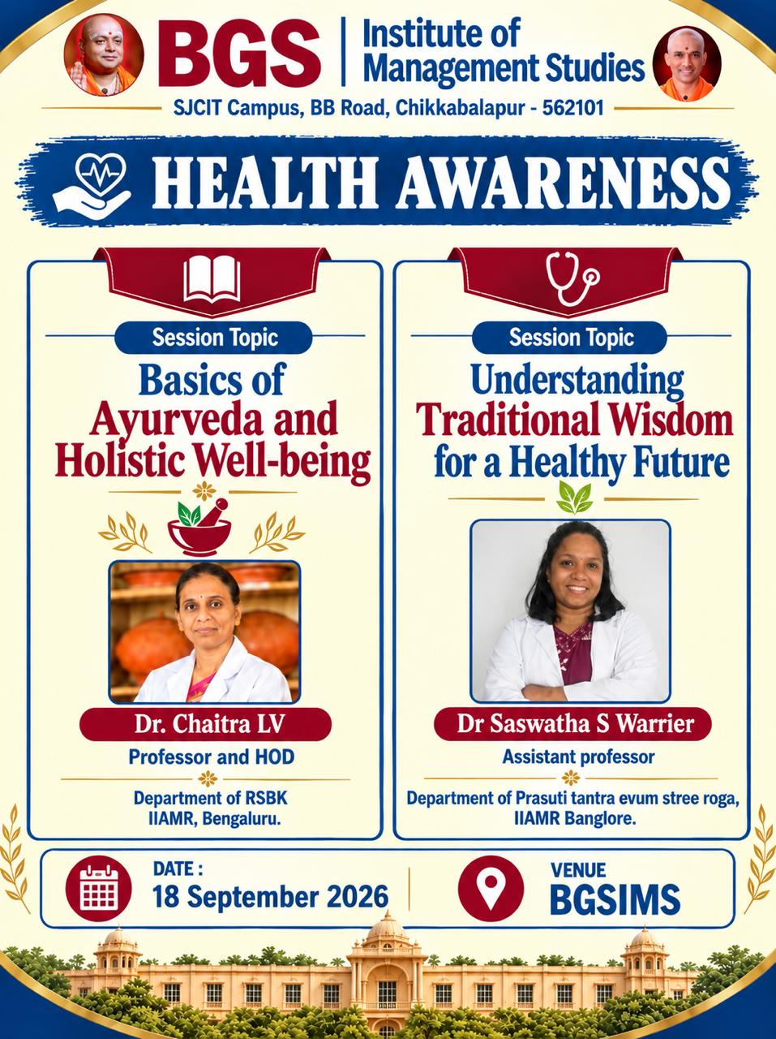
Name of the Programme: Health Awareness Programme
Date:18 September 2026
Venue: BGSIMS
Participants: Students and Faculty Members

BGS Institute of Management Studies organised a Health Awareness Programme on 18 September 2026 at BGSIMS to create awareness among students and faculty members about the importance of health, preventive care, holistic well-being and traditional approaches to maintaining a healthy lifestyle. The programme featured two informative sessions focusing on the basics of Ayurveda and holistic well-being and the role of traditional wisdom in promoting a healthy future.
Objectives of the Programme
- To create awareness about the basic principles and significance of Ayurveda.
- To promote the importance of holistic health and overall well-being.
- To introduce participants to traditional approaches to maintaining good health.
- To encourage healthy lifestyle practices and preventive healthcare.
- To help students and faculty understand the relevance of traditional wisdom in contemporary health and well-being.
Details of the Sessions
Session 1: Basics of Ayurveda and Holistic Well-being
The first session, titled “Basics of Ayurveda and Holistic Well-being,” was conducted by Dr. Chaitra LV, Professor and HOD, Department of RSBK, IIAMR, Bengaluru.
The session provided participants with an introduction to Ayurveda and its approach to health and well-being. The speaker explained the importance of maintaining balance and harmony in different aspects of life and highlighted the holistic nature of Ayurveda.
The session also created awareness about the importance of healthy habits, appropriate food practices, physical well-being and preventive approaches to maintaining good health. Participants gained a basic understanding of how traditional health practices can contribute to overall well-being when followed appropriately and responsibly.
Session 2: Understanding Traditional Wisdom for a Healthy Future
The second session, titled “Understanding Traditional Wisdom for a Healthy Future,” was conducted by Dr. Saswatha S Warrier, Assistant Professor, Department of Prasuti Tantra Evum Stree Roga, IIAMR, Bangalore.
The session focused on the relevance of traditional wisdom in promoting a healthy lifestyle and improving awareness about personal well-being. The speaker highlighted the importance of understanding traditional health practices and applying appropriate knowledge in daily life.
The session encouraged participants to develop greater awareness about their health and to adopt suitable healthy practices. The discussion also emphasised the importance of responsible health choices and seeking appropriate professional guidance whenever required.
The Health Awareness Programme provided valuable insights into Ayurveda, holistic well-being and traditional approaches to health. Participants gained awareness about the importance of maintaining a balanced and healthy lifestyle. The sessions also encouraged students and faculty members to develop positive health habits and to understand the relevance of traditional wisdom in contemporary life.
The Health Awareness Programme was an informative and meaningful initiative organised by BGS Institute of Management Studies. The two sessions provided participants with useful knowledge about Ayurveda, holistic well-being and traditional wisdom for a healthy future. The programme successfully encouraged students and faculty members to become more conscious of their health and to adopt appropriate practices for maintaining overall well-being.

FACULTY  CO-ORDINATOR | IQAC  COORDINATOR | PRINCIPAL
