REPORT ON CHARACCOS – CMA/CA INAUGURATION PROGRAMME
Date: 1 October 2026
Time: 1:30 PM onwards
Venue: BGS Institute of Management Studies, Chikkaballapur
BGS Institute of Management Studies (BGSIMS), Chikkaballapur, organised the inauguration of CHARACCOS – CMA/CA Programme on 1 October 2026 with the objective of creating awareness among students about professional opportunities in Cost and Management Accountancy (CMA) and Chartered Accountancy (CA).
The programme was organised to encourage B.Com and BBA students to pursue professional qualifications alongside their regular academic studies. It aimed to introduce students to career opportunities in accounting, finance, taxation, auditing, cost management, and corporate management.
The programme commenced with an assembly, followed by an invocation song rendered by Ms. Sharadha. Mr. Ravi N, Assistant Professor, Department of M.Com welcome address formally welcomed the dignitaries, faculty members, and students. The traditional Jyothi Prasarana ceremony was performed by the dignitaries, marking the formal inauguration of the programme.
The event was graced by distinguished dignitaries, including CMA Dr. Abhijeet S Jain, Former Chairman of the Institute of Cost Accountants of India (ICMAI), Bengaluru Chapter, as the Chief Guest; Dr. N Shivarama Reddy, Chief Administrative Officer, Sri Adichunchanagiri Shikshana Trust (R), as the Guest of Honour; and Dr. N Madhusudhan, Dean, BGS Institutions, and Mr. Manjunatha N, Principal, BGSIMS, as the dignitaries in attendance. The programme also acknowledged the divine blessings of the revered spiritual leaders of Sri Adichunchanagiri Mahasamsthana Math.
Mr. Manjunatha N delivered the keynote address, highlighting the importance of professional education and career-oriented learning. CMA Dr. Abhijeet S Jain addressed the students on the benefits of pursuing CMA and explained the professional opportunities available in accounting, finance, and management. Dr. N Madhusudhan delivered the Dean’s address, followed by an oath-taking ceremony. Dr. N Shivarama Reddy delivered the presidential address, emphasising the importance of discipline, commitment, and continuous learning in achieving professional success.
The programme concluded with a vote of thanks delivered by a student, expressing gratitude to the dignitaries, management, faculty members, and students for their support and participation.
Outcome: The inauguration marked an important step towards promoting professional education at BGSIMS. CHARACCOS aims to provide structured coaching, regular assessments, mock tests, and academic guidance to prepare students for professional examinations and strengthen their career prospects.
The programme concluded successfully with the collective support of the management, dean, principal, faculty members, and students of BGSIMS.
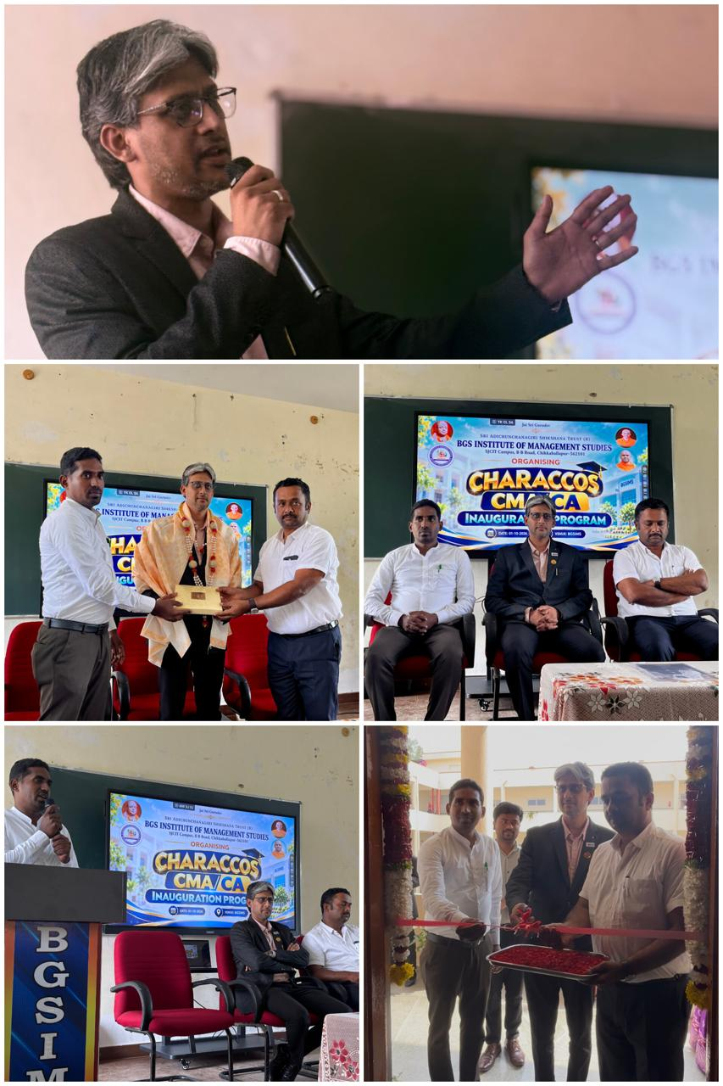
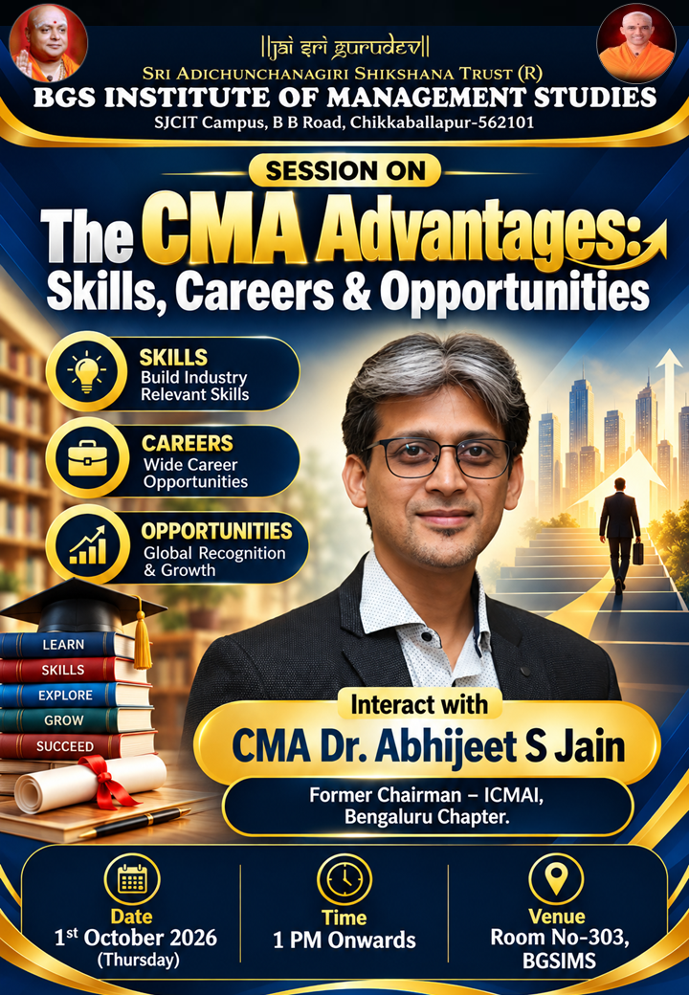
Reported By:
Mr. Ravi N
Assistant Professor
Department of M.Com
BGS Institute of Management Studies, Chikkaballapur-562101

Academic Administrator Principal

