|| JAI SRI GURUDEV ||
Sri Adichunchanagiri Shikshana Trust ®
B.G.S INSTITUTE OF MANAGEMENT STUDIES SJCIT campus,
Chickballapur – 562101

REPORT ON ALUMNI TALK
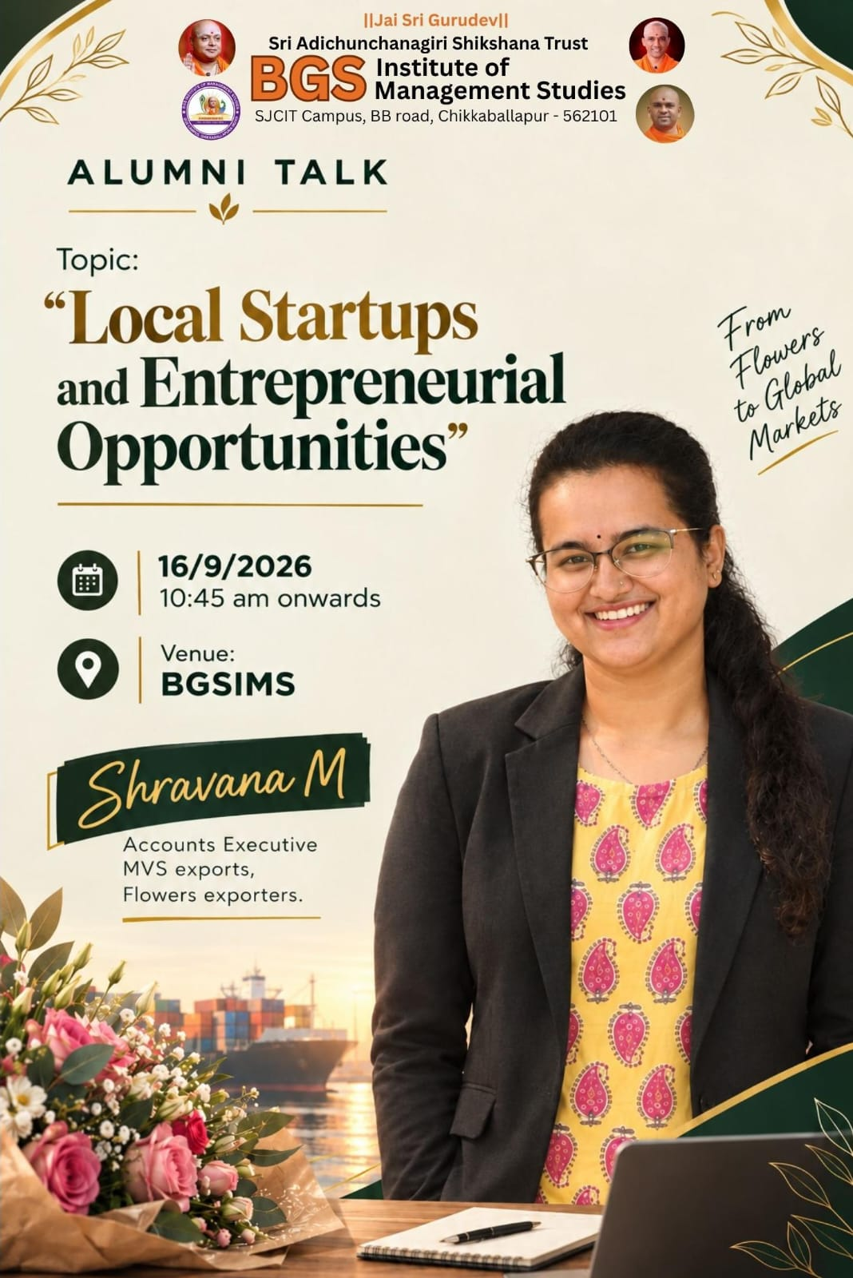
Topic: “Local Startups and Entrepreneurial Opportunities”
Date: 16 September 2026
Time: 10:45 AM onwards
Venue: BGS Institute of Management Studies (BGSIMS)
Organized by: BGS Institute of Management Studies, SJCIT Campus, Chikkaballapur
BGS Institute of Management Studies, Chikkaballapur, organized an Alumni Talk on the topic “Local Startups and Entrepreneurial Opportunities” on 16 September 2026. The programme was organized for the benefit of students to create awareness about entrepreneurship, local business opportunities, export markets, and the importance of developing entrepreneurial skills.
The session was delivered by Ms. Shravana M, Accounts Executive at MVS Exports, Flowers Exporters. The talk provided students with practical insights into the flower export business, international markets, and the opportunities available for young entrepreneurs.
Objectives of the Programme
- To create awareness among students about local startups and entrepreneurial opportunities.
- To provide practical knowledge about the flower export industry and international markets.
- To explain the role of export businesses in connecting local producers with international dealers.
- To motivate students to explore entrepreneurship and develop business skills.
Proceedings of the Programme
The Alumni Talk commenced at 10:45 AM. Ms. Shravana M addressed the students and shared valuable insights from her experience in the export industry. She explained the significance of flowers as an export commodity and discussed the opportunities available in the domestic and international flower markets.
The speaker highlighted the importance of understanding market demand, maintaining product quality, and establishing good relationships with international dealers. She explained that the flower export business requires proper planning, coordination, timely delivery, and an understanding of customer requirements in different countries.
The session also focused on the role of local businesses in reaching global markets. Students were introduced to the potential of converting locally available resources into business opportunities through innovation, marketing, and entrepreneurship. The speaker encouraged students to develop knowledge of international trade and explore new business ideas.
Key Takeaways from the Session
- Flower Export Business: Students gained an understanding of the flower export sector and its potential to create entrepreneurial opportunities.
- International Flower Markets: The importance of studying international market demand, customer preferences, and market trends was highlighted.
- International Dealers: The speaker explained the significance of building strong business relationships with international dealers and maintaining quality and timely delivery.
- Entrepreneurial Opportunities: Students were motivated to identify local business opportunities and explore the potential for expanding businesses into international markets.
- Practical Business Knowledge: The session provided exposure to real-world business operations and the importance of planning, coordination, and market understanding.
The Alumni Talk on “Local Startups and Entrepreneurial Opportunities” was an informative and valuable programme for the students of BGS Institute of Management Studies. The insights shared by Ms. Shravana M on flower exports, international markets, and dealer relationships helped students understand the practical aspects of entrepreneurship and global business.
The programme encouraged students to explore local business opportunities, develop entrepreneurial skills, and consider the potential of taking local products to international markets. The session successfully contributed to enhancing students’ awareness of entrepreneurship and export-oriented business opportunities.

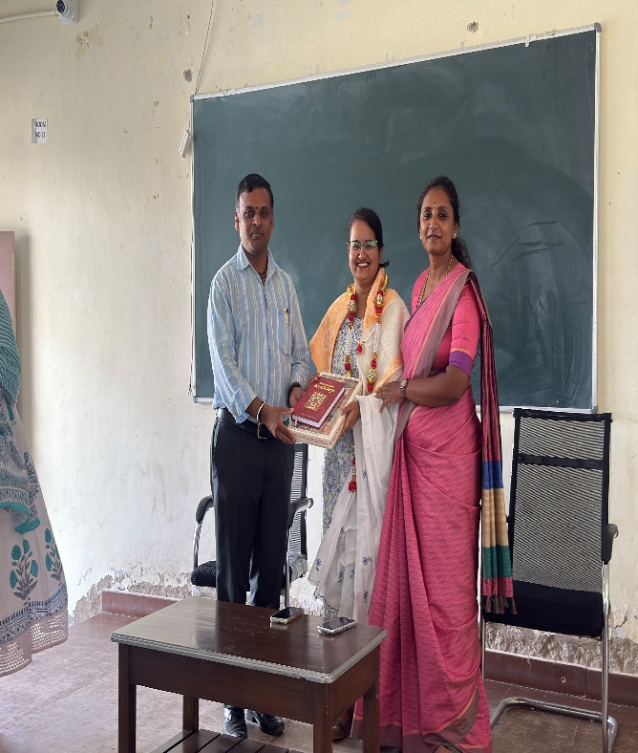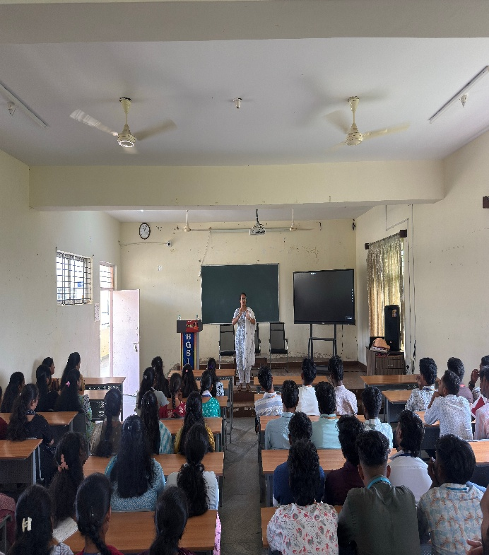
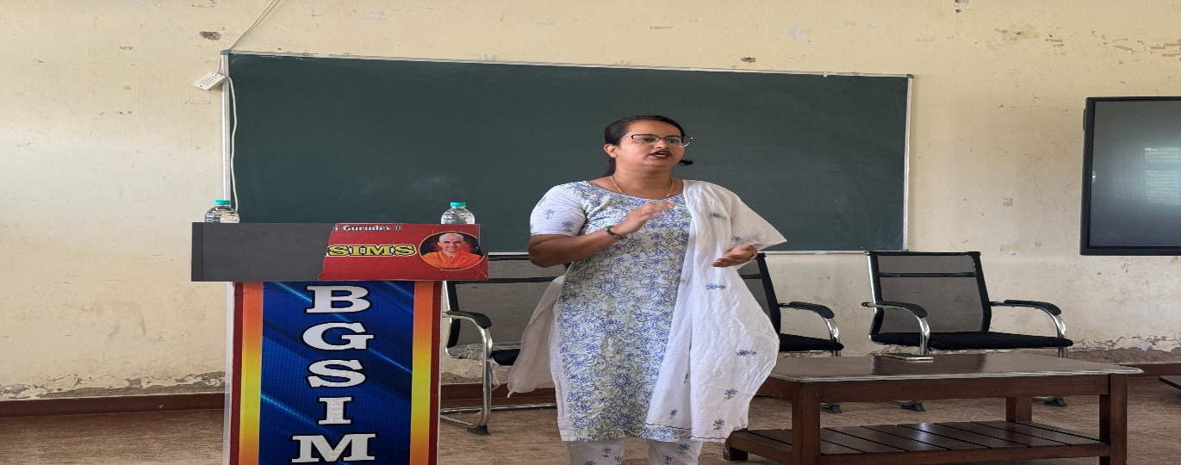

ALUMNI TALK  CO-ORDINATOR | IQAC  COORDINATOR | PRINCIPAL

