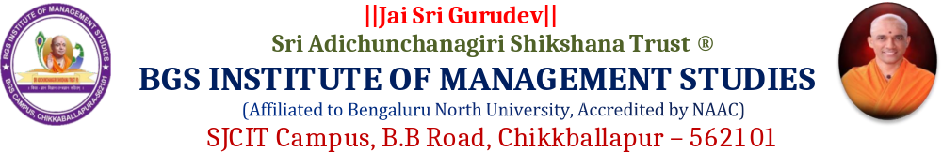

REPORT ON “CLASSROOM TO CAREER” SESSION
1. | Title | “CLASSROOM TO CAREER”
2. | Venue | BGS Conference Hall
3. | Date & Time | 08/09/2026 at 10.30 AM
4. | Resource Person | Dr. N. Shivarama Reddy, CAO, SAST
5. | Beneficiary Students | I sem B.Com & BBA Students
6. | Organised by. | BGS Institute of Management Studies, Chikkballapur.

BGS Institute of Management Studies organised a career-oriented session titled “Classroom to Career” for the first-year students of BBA and B.Com on 8 September 2026 at the BGS Conference Hall. The session was delivered by Dr. N. Shivarama Reddy, Chief Administrative Officer (CAO), Sri Adichunchanagiri Shikshana Trust, with the objective of sensitising students to the competencies and professional attributes required to successfully progress from academic life to the workplace.
The session provided students with valuable insights into the importance of establishing clear career goals at the beginning of their undergraduate journey. Dr. N. Shivarama Reddy emphasised that students should identify their interests, strengths and career aspirations and align their academic efforts with their long-term professional objectives. He encouraged students to approach their degree programme with a clear purpose and to make effective use of the learning opportunities available to them.
A major focus of the session was the development of strong subject knowledge and practical skills. The resource person highlighted that academic success should extend beyond examination-oriented learning and encouraged students to understand concepts thoroughly and relate classroom learning to real-world business situations. Students were motivated to participate in projects, presentations, case studies, internships and other experiential learning activities to strengthen their ability to apply theoretical knowledge in practical contexts.
The importance of communication skills was also highlighted as an essential component of career readiness. Students were encouraged to develop confidence in speaking, listening, presenting ideas and interacting effectively with others. The resource person explained that strong communication skills contribute significantly to performance in interviews, group discussions, teamwork, leadership roles and professional environments.
The session further addressed the growing significance of digital competence in contemporary education and employment. Students were encouraged to acquire relevant digital skills and remain adaptable to emerging technologies. The resource person emphasised that effective use of digital tools, continuous technology awareness and willingness to learn new systems are increasingly important for professional success across business and commerce-related careers.
Another key area of discussion was the development of a professional personality. Students were guided on the importance of discipline, punctuality, confidence, positive attitude, responsibility, teamwork, adaptability and professional conduct. The resource person stressed that professional personality is developed gradually through consistent behaviour, self-discipline and active participation in academic and co-curricular activities.
The session also focused on employment and employability, making students aware that a degree qualification alone may not be sufficient to meet workplace expectations. Students were encouraged to develop a balanced combination of subject knowledge, practical competence, communication ability, digital skills and professional attitude. They were motivated to begin preparing early for future employment opportunities and to continuously strengthen their employability profile.
Time management was discussed as an important personal and professional skill. The resource person advised students to plan their activities effectively, prioritise responsibilities and maintain a healthy balance between academic work, skill development and other institutional activities. Students were encouraged to use their time productively and develop consistent habits that would support their academic performance and future career progression.
The session concluded with an emphasis on becoming a lifelong learner. Dr. N. Shivarama Reddy explained that learning should continue beyond the completion of a degree and that professionals need to continuously update their knowledge and skills in response to changing industry requirements. Students were encouraged to cultivate curiosity, read regularly, learn from experiences and remain open to new knowledge, technologies and opportunities.
The session was interactive and provided students with an opportunity to gain practical perspectives on career preparation and professional development. The guidance offered by the resource person helped students understand the close relationship between classroom learning, skill development and career readiness. It also encouraged them to take greater responsibility for their academic progress and personal development from the early stages of their undergraduate education.
Overall, the “Classroom to Career” session was successfully conducted and served as a valuable career-orientation initiative for the first-year BBA and B.Com students. The programme effectively addressed the key dimensions of career development, namely Career Goals, Subject Knowledge, Practical Skills, Communication Skills, Digital Competence, Professional Personality, Employment, Time Management and Lifelong Learning. The session contributed to enhancing students’ career awareness and motivated them to develop the knowledge, skills, attitude and professional competencies necessary for their future academic and career success.

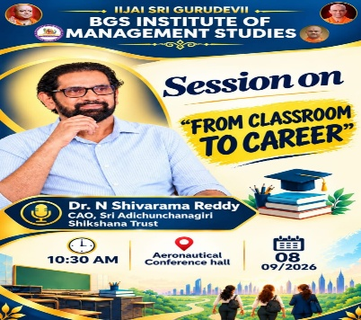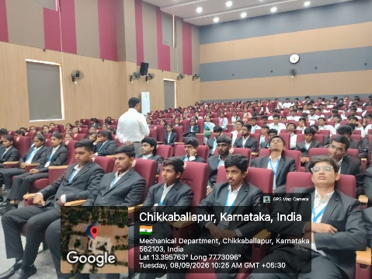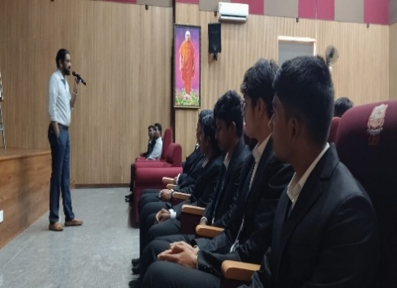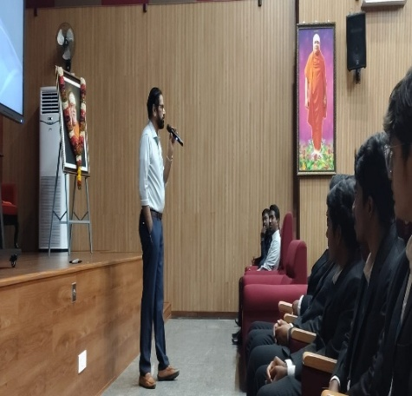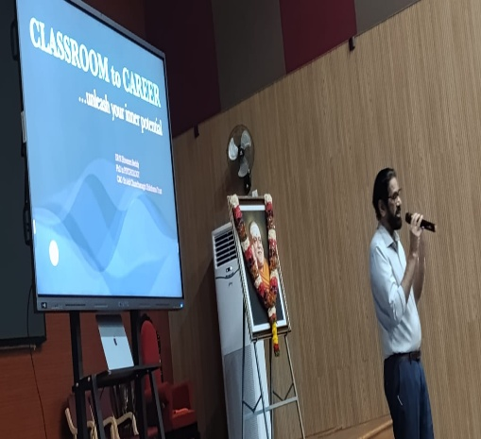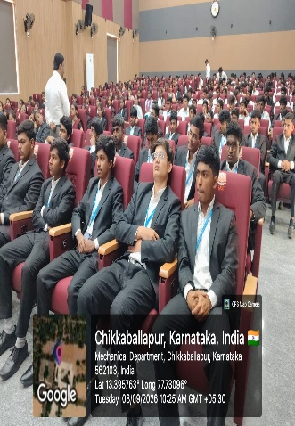
POST MEETING DISCUSSION
After the completion of the “Classroom to Career” session, the Principal reviewed the overall conduct and execution of the programme. The discussion included the discipline and behaviour of the students, punctuality, participation, and the overall arrangements made for the session.
The Principal also reviewed how effectively the programme was carried out, including the involvement of students, coordination among the faculty members, and the smooth management of the session. The positive aspects of the programme were appreciated, while areas that could be improved were also discussed.
The meeting further focused on ways to improve future programmes by strengthening planning, coordination, student participation, time management, and discipline. Suggestions were discussed to make upcoming academic and career-oriented programmes more interactive, organised, meaningful, and successful.
Overall, the review helped the organisers identify the strengths of the programme as well as areas requiring further attention. The feedback and suggestions discussed will be useful in planning and conducting more effective programmes in the future.
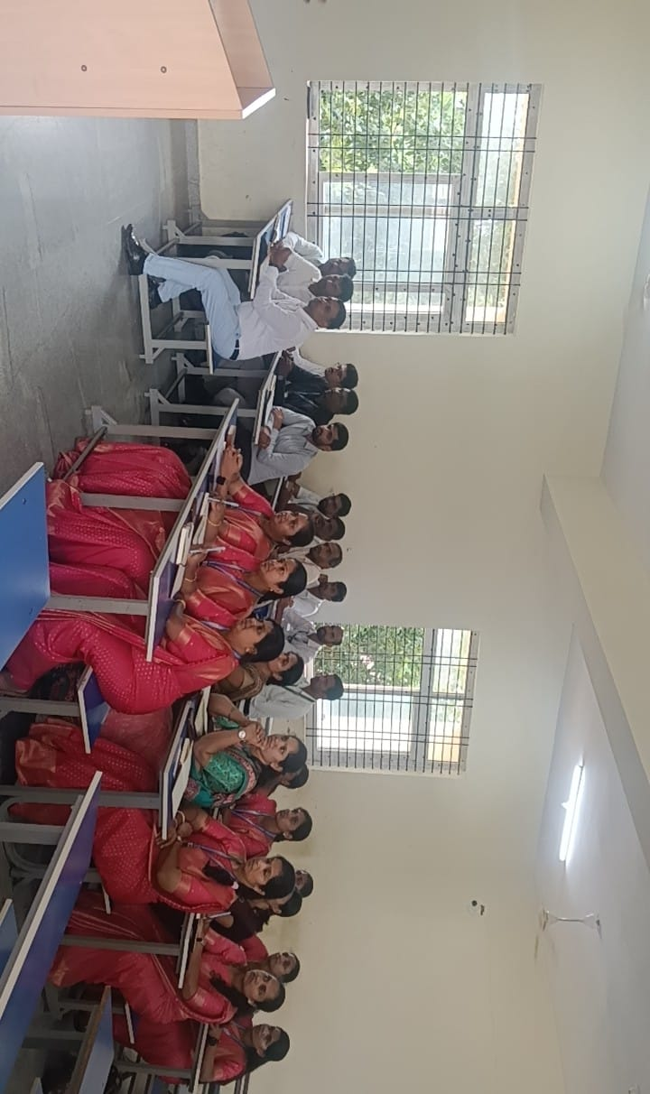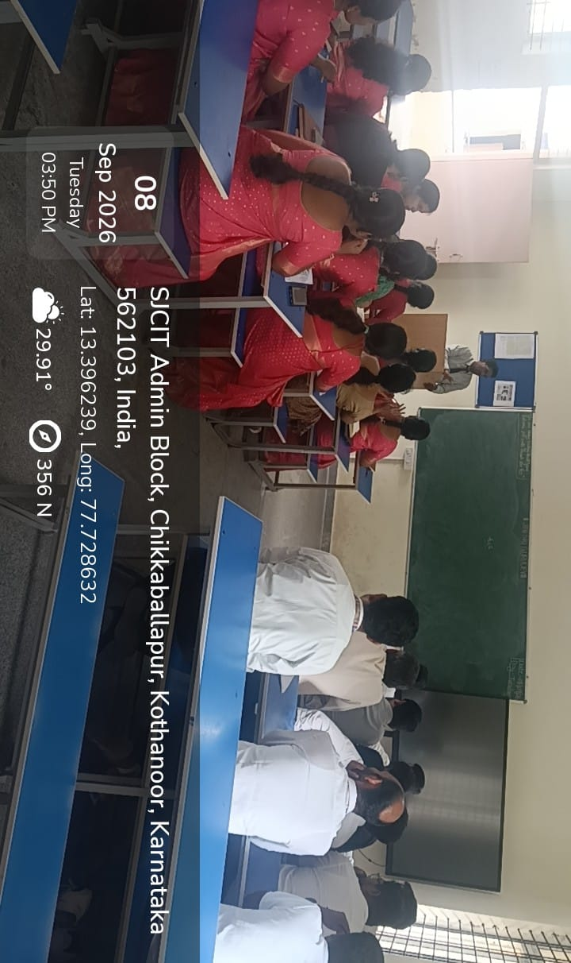

Co-Ordinator Academic Administrator Principal

